**TC USER GUIDE DOCUMENT**

TEAMCENTER LOGIN:

Enter user id and password

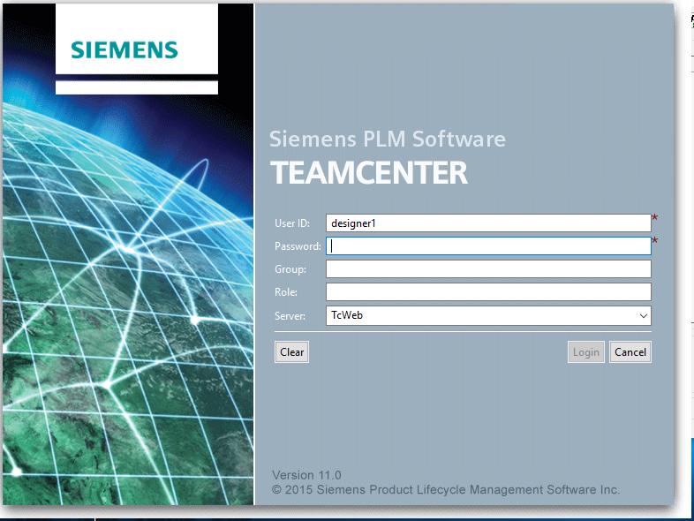

MY TEAMCENTER APPLICATION WILL OPEN ON SCREEEN

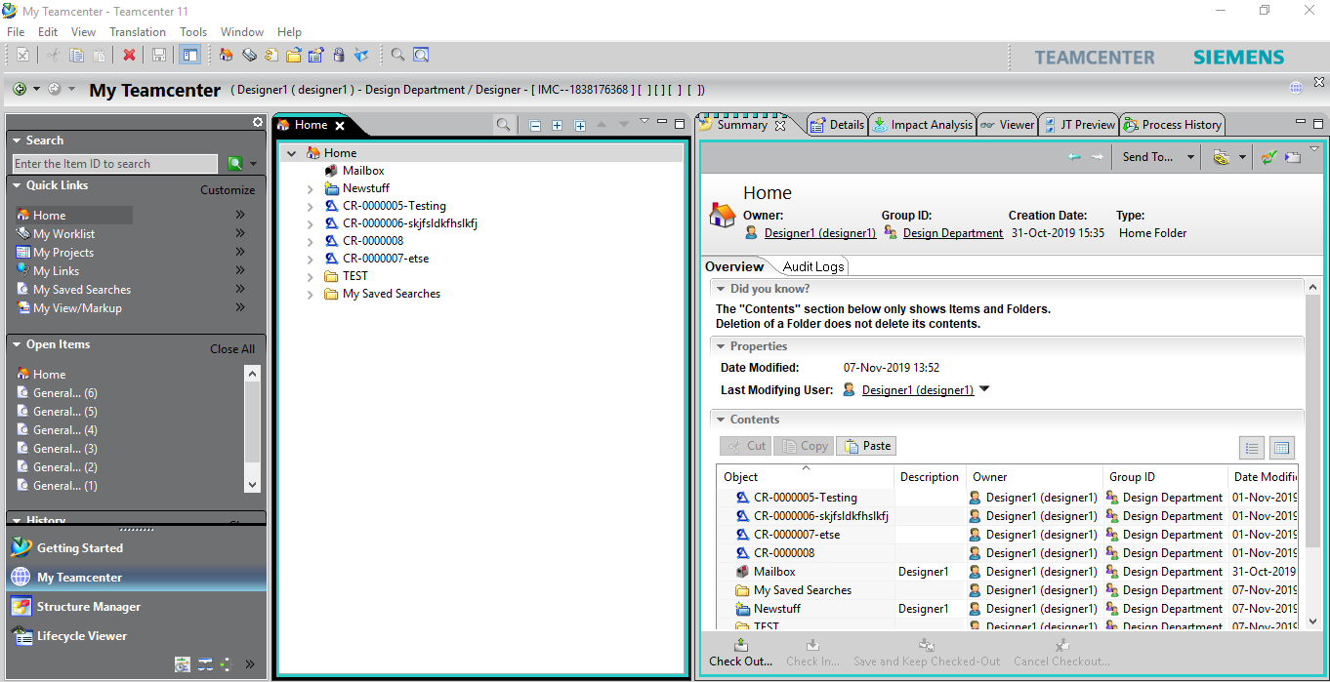

USER DETAILS WILL BE DISPLAYED AT APPLICATION BANNER ON SCREEN



**TO CREATE A NEW WORKING DIRECTORY:**

FILE🡪 NEW 🡪FOLDER OR PRESS Cntrl+Alt+F

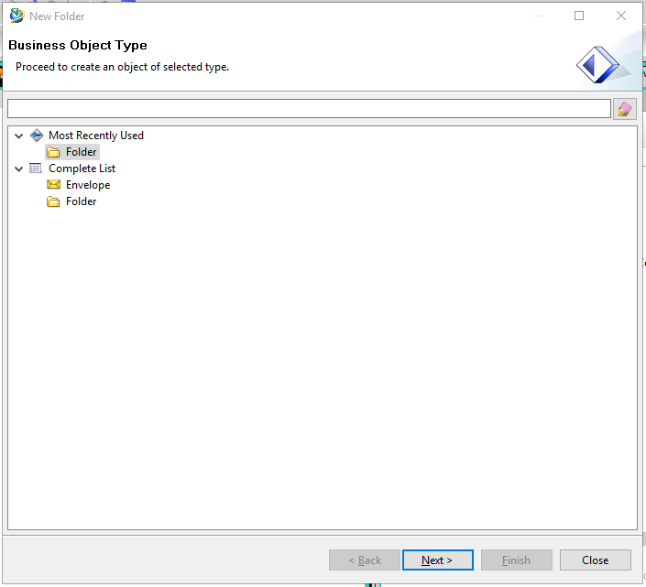

Click on next and fill the details and click finish:

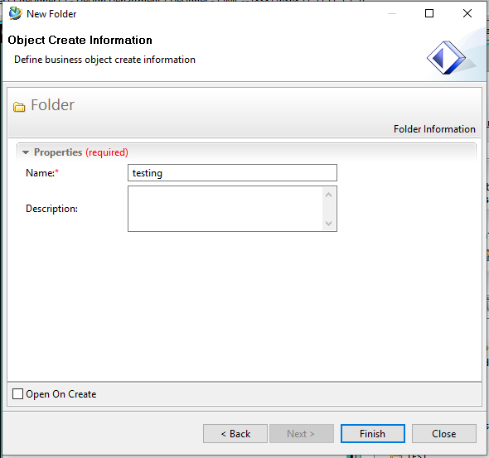

New folder with the given name will be created

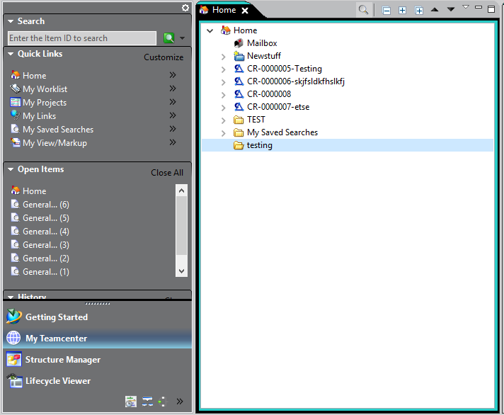

**CREATING A NEW ITEM IN TEAMCENTER**

The select the folder under which you want your item to be created .

In my case I am created new **Design item** under **testing** folder.

To create new item File🡪 New🡪 Item or press Cntrl+t and select Design item.

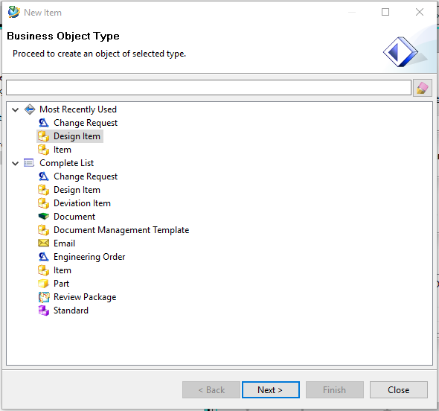

For RND item directly select assign and enter the name for the Item.

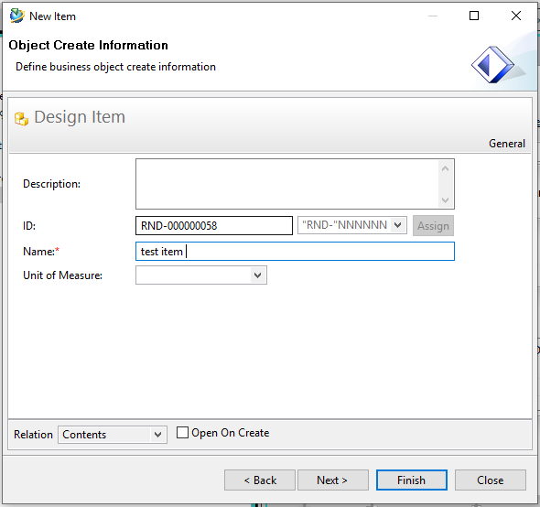

Click finish , item will be created in the respective folder.

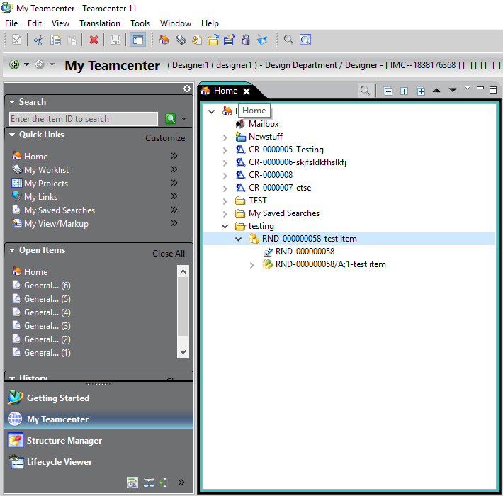

To create design item with manual part numbering.

Follow the same above process but instead of clicking assign button enter the item id field manually.

And give the name to the item.

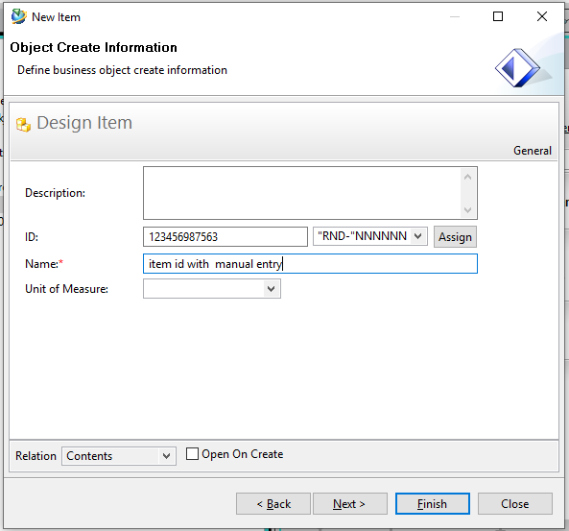

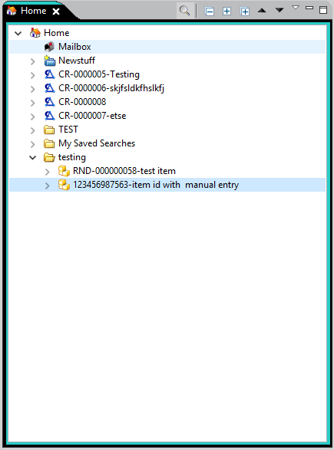

**Attach Dataset**

Select revision on which you want to add dataset.

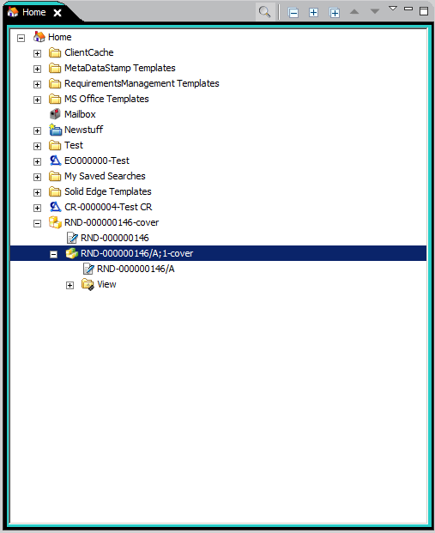

File -> New -> Dataset (ctrl+D)

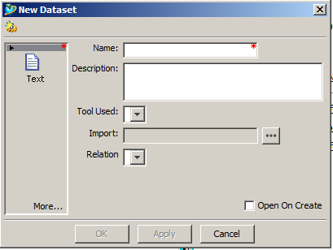

Click on more and select type of dataset you want to add.

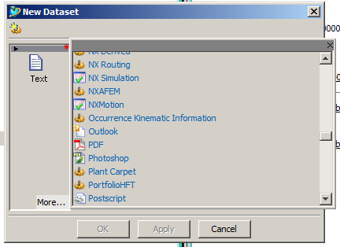

Give name or it will take same as selected item revision.

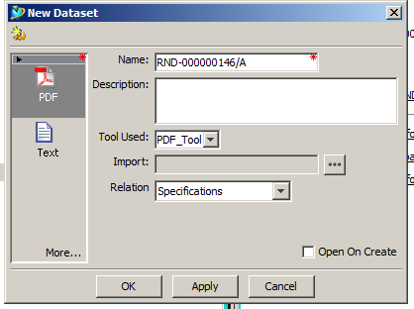

To add named reference click on Import and select dataset typr file and select the relation which you want to add.

Click OK.

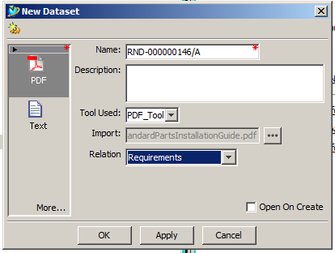

Check -in and check-out of item of modification

Select the item revision which you want to check -out and press check -out tab from summary view.

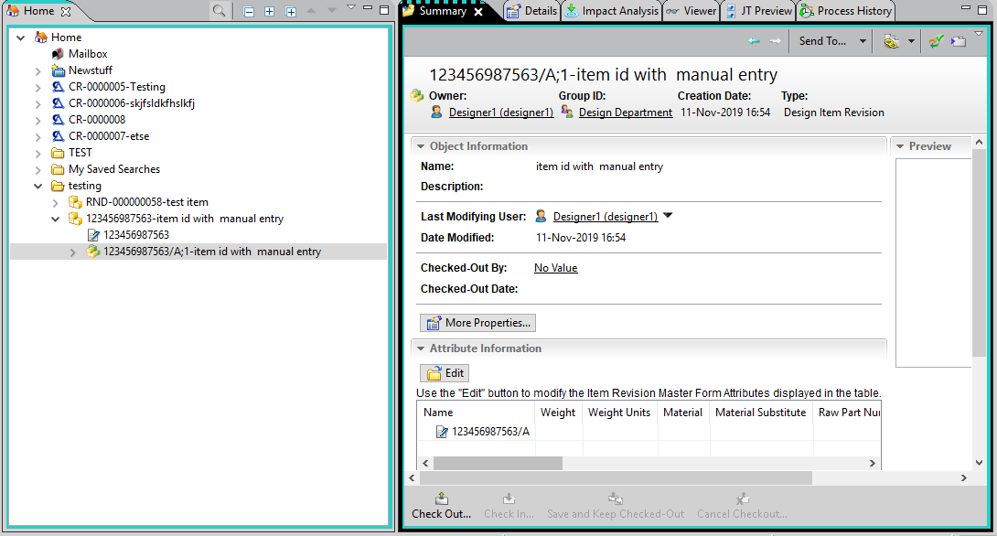

To check in after check out in summary view click on the check in button.

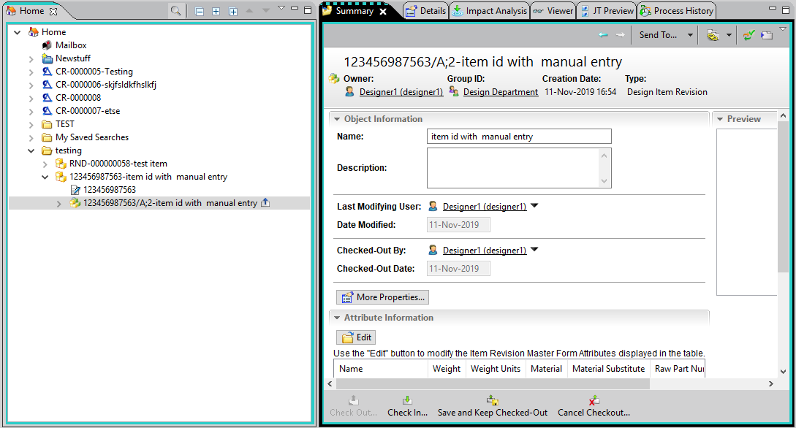

Properties of any object can be viewed in viewer tab under ALL tab.

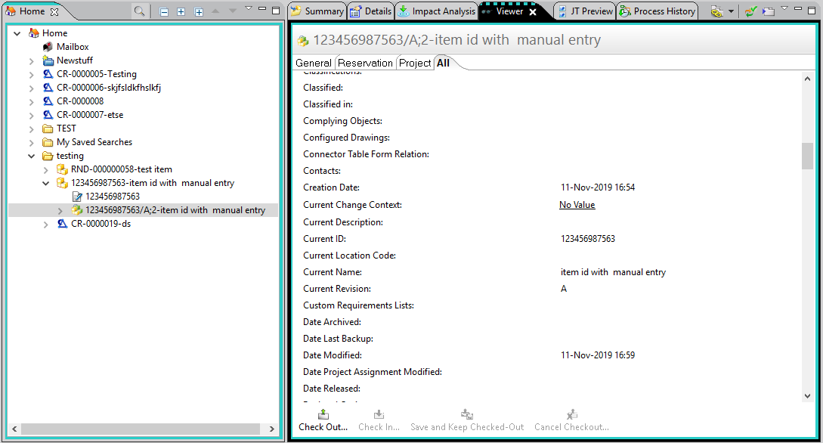

Create **CR Item** in Teamcenter.

File -> New -> Item select **Change Request** item.

Click **Next.**

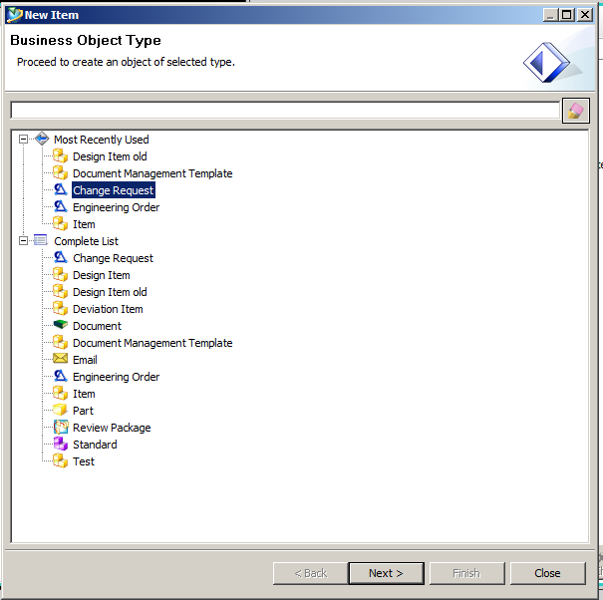

Click on Assign.

Give Name and click Finish.

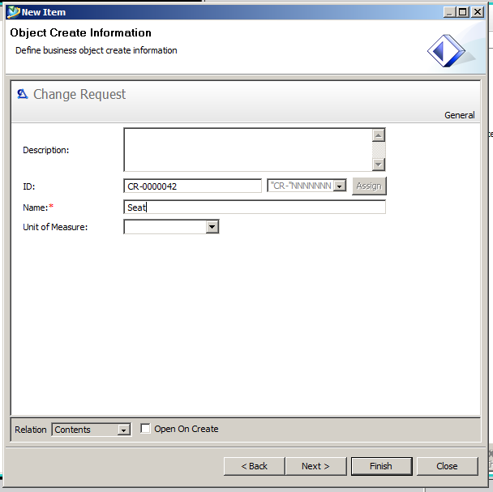

SEARCHING ITEMS IN TEAMCENTER

Enter the item id in the search box provided and click on search icon.

NOTE: wild card entries is allowed in search box (eg:*563)

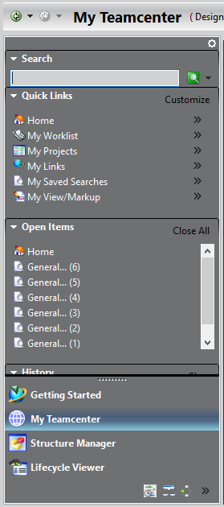

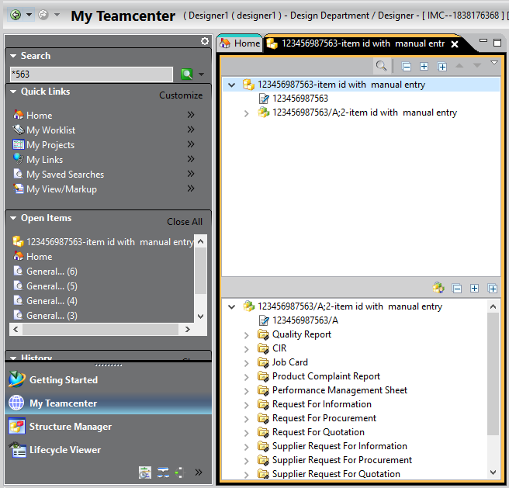

Results displayed

Searching Design item from search criteria:

Click on open search view icon 

Click select search

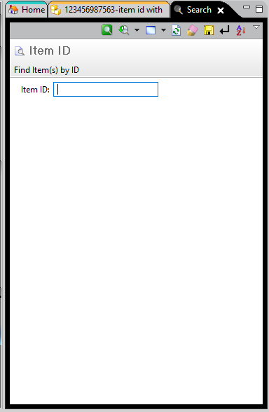

Select the type of search you want to perform fill the details and press enter

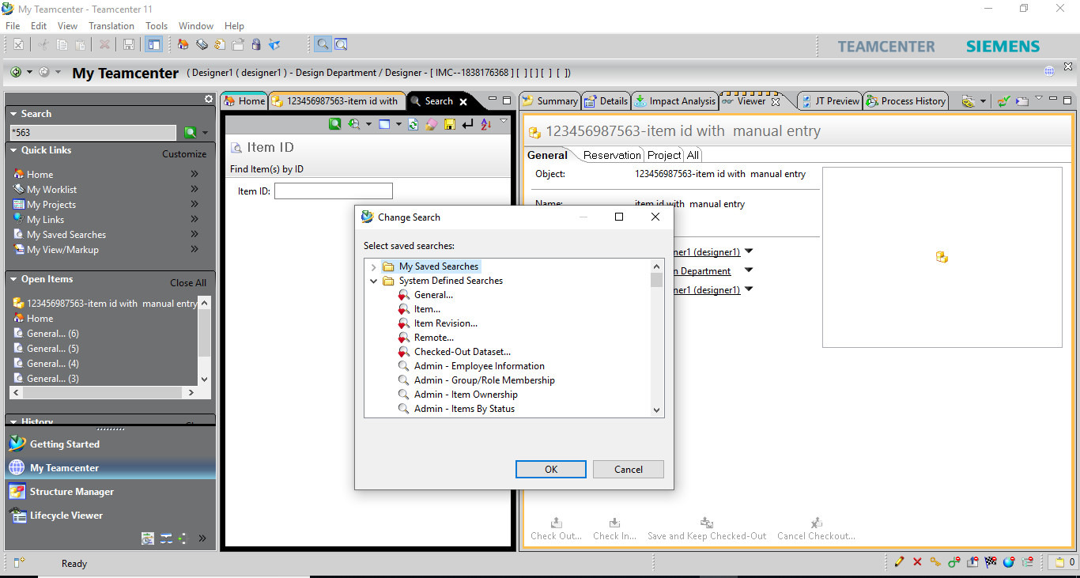

Below image shows the search criteria details to be filled

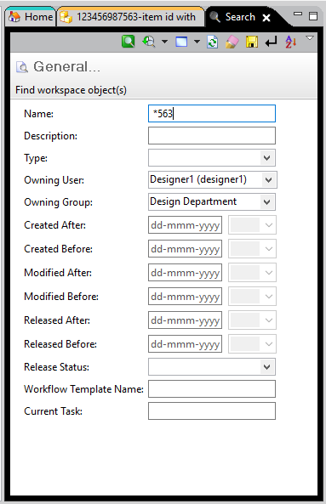

**Organization:**

In my teamcenter application click on the organization icon from bottom left corner

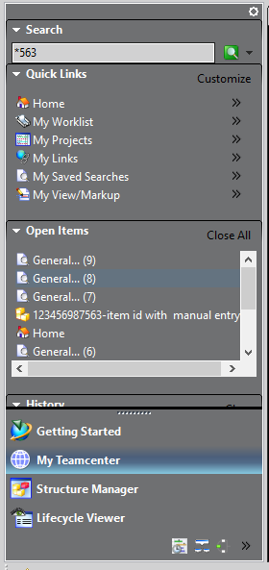

Organization application will open.

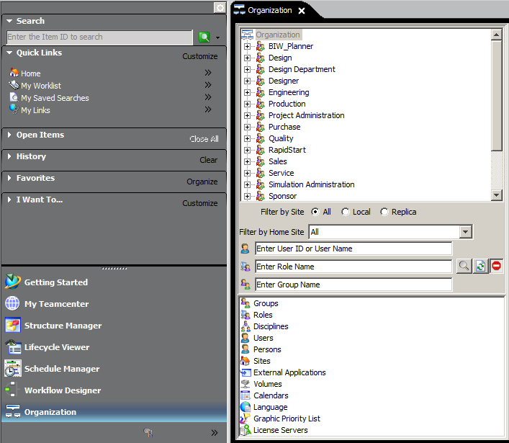

To create **Group** select Groups in **Organization List Tree** fill name and click on create.

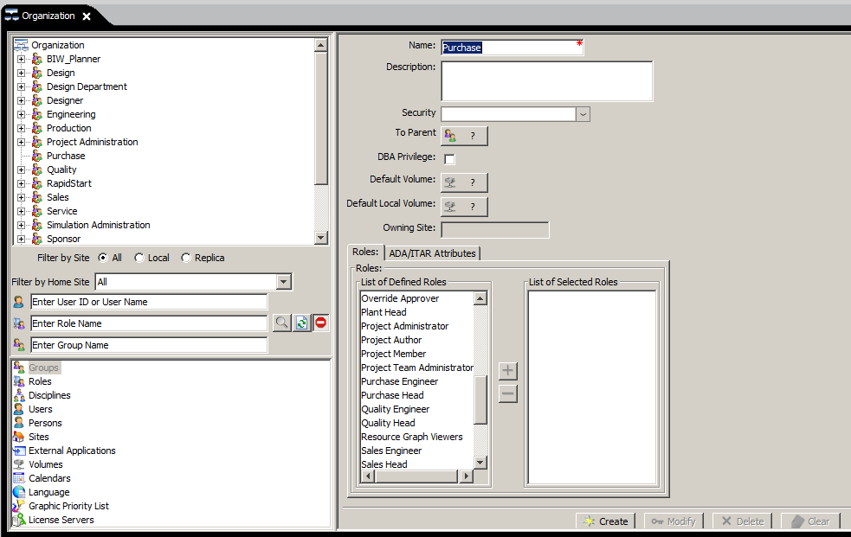

After click on create Group will appear in **Organization Tree**.

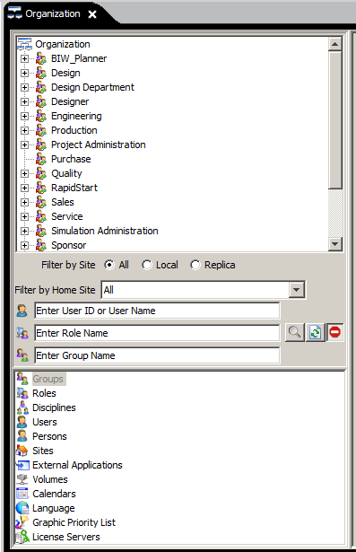

Add **Role** to **Purchase** group.

Select **Purchase** group from **Organization Tree** and click on **Add Role.**

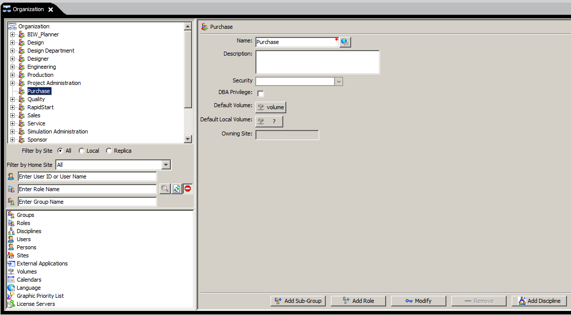

New window will appear select **Add existing role to the group** and click **Next.**

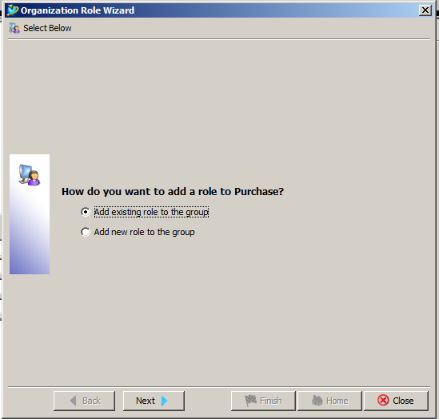

New window will appear.

Select role from already **Existing Roles** click on **‘+’** button it will transfer to the **Selected Roles** column click **Finish.**

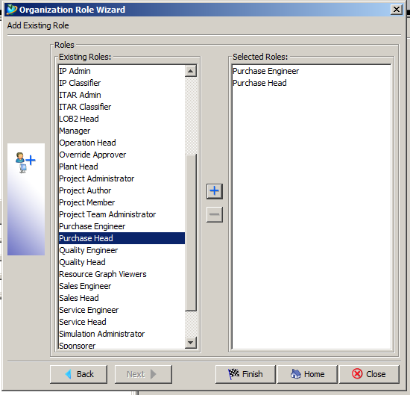

Roles will appear under particular group in **Organization Tree.**

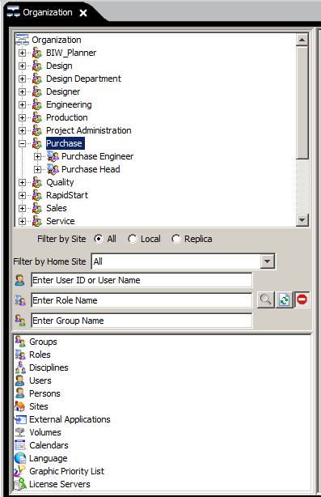

Add new role to group

Select group and click on **Add Role.**



Select **Add new role to the group** and click **Next.**

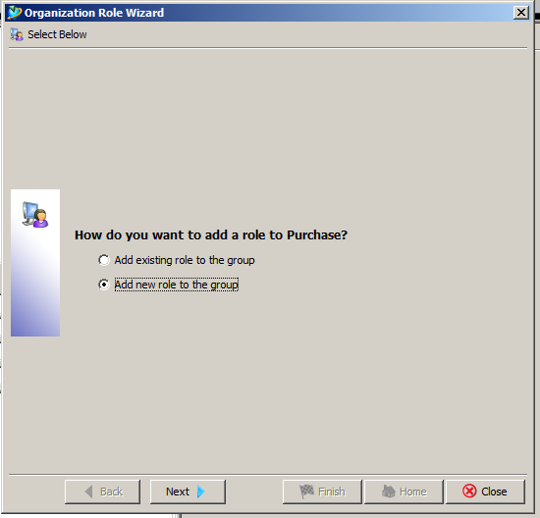

Give **Role** and click **Finish** it will get added to particular selected group**.**

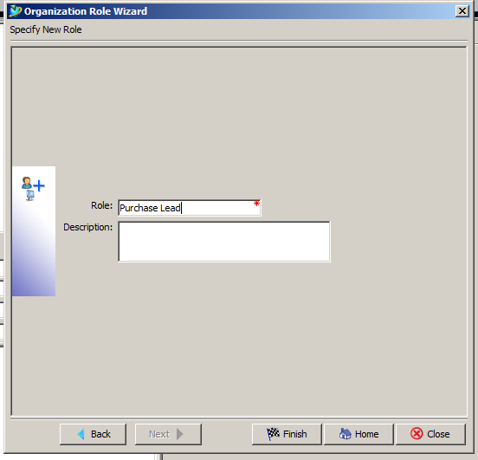

To add **Users** in particular **Role** first we have to create **Person.**

Select **Persons** from **Organization List Tree.**

Fill information **Name** is mandatory click on **Create.**

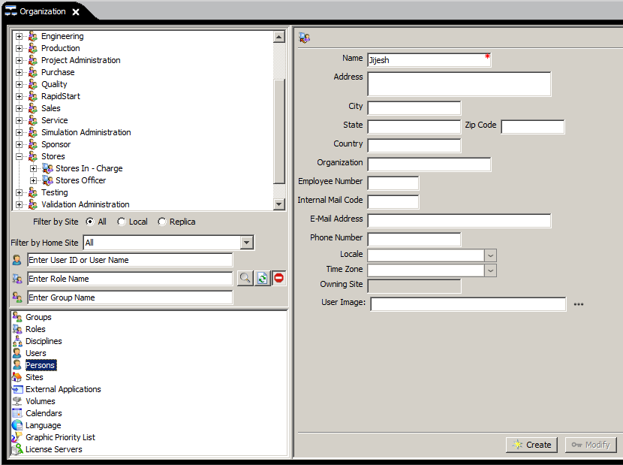

Select **Users** from **Organization List Tree.**

Select person name.

Give **User ID, OS Name, Password** and **Default Group** click on **Create** and user will get created**.**

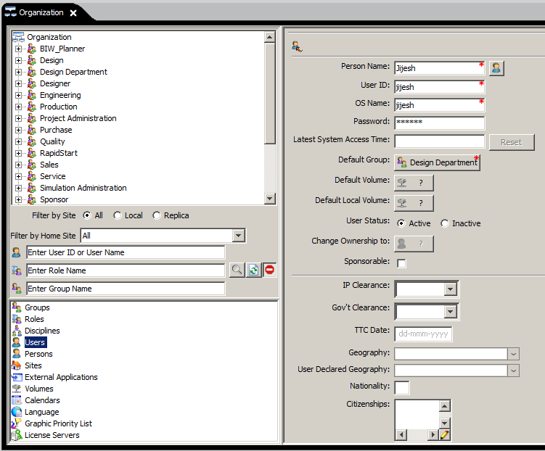

Add user to role.

Select **Role** click on **Add User.**

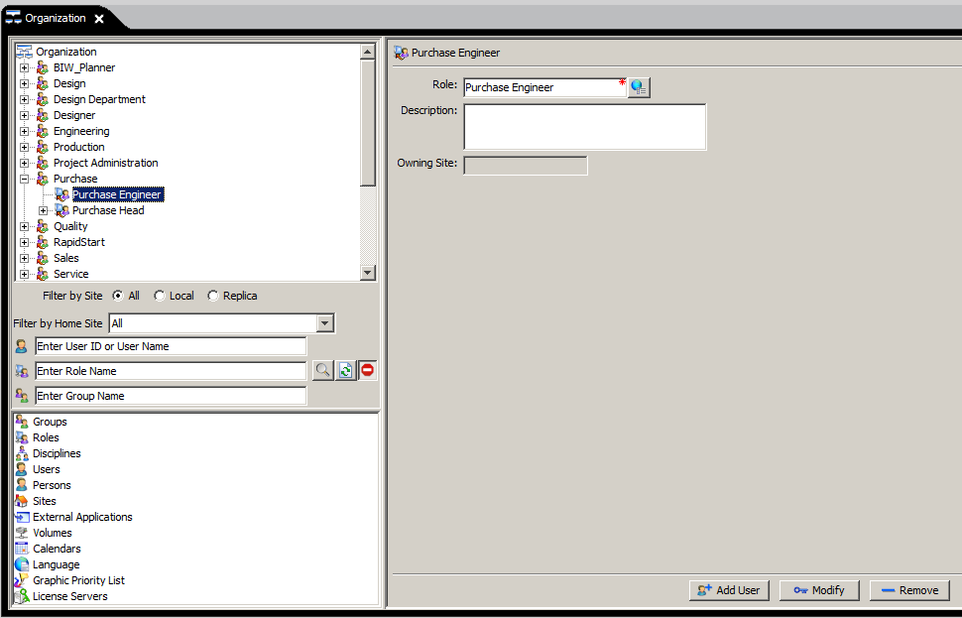

Select **Add existing user to the group/role.**

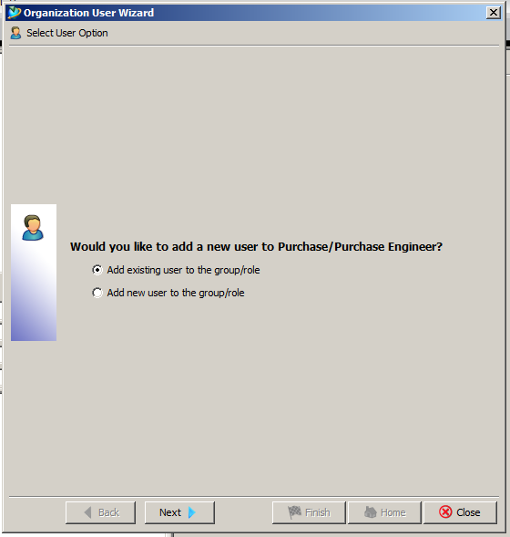

Select **User** from **Available Users** click **‘>’** button and click on finish.

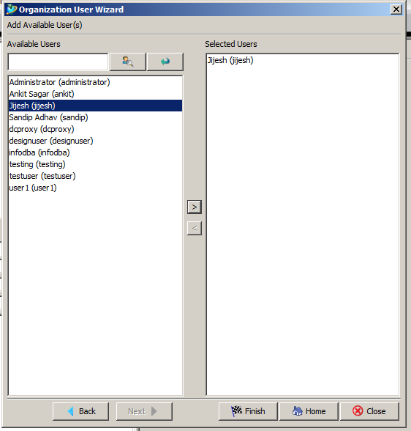

User will get added to particular role.

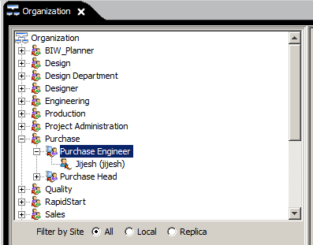

**Initiate Workflow Process**

**NOTE: Workflow process can not initiated by dba group members.**

Select revision on which you want to initiate the workflow.

File -> New -> Workflow Process (ctrl+P)

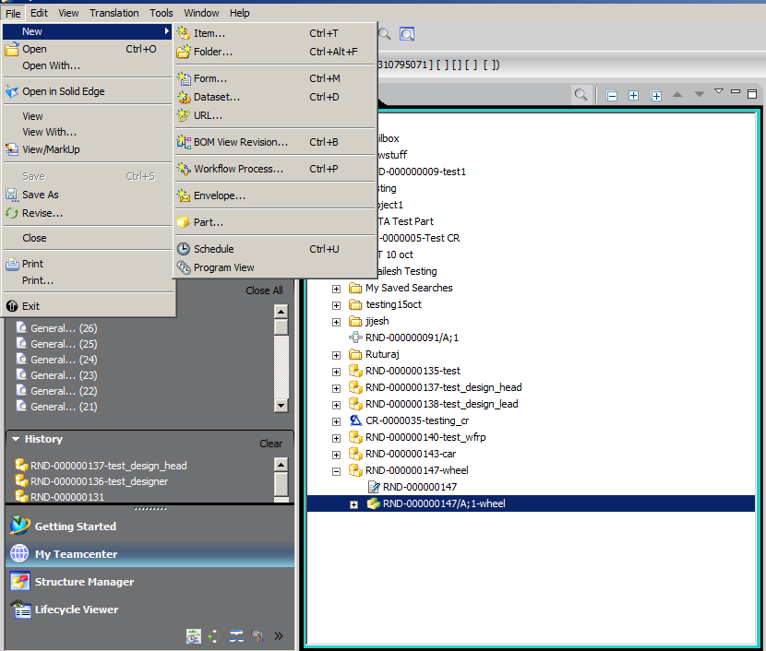

Select **Process Template** which you want to initiate

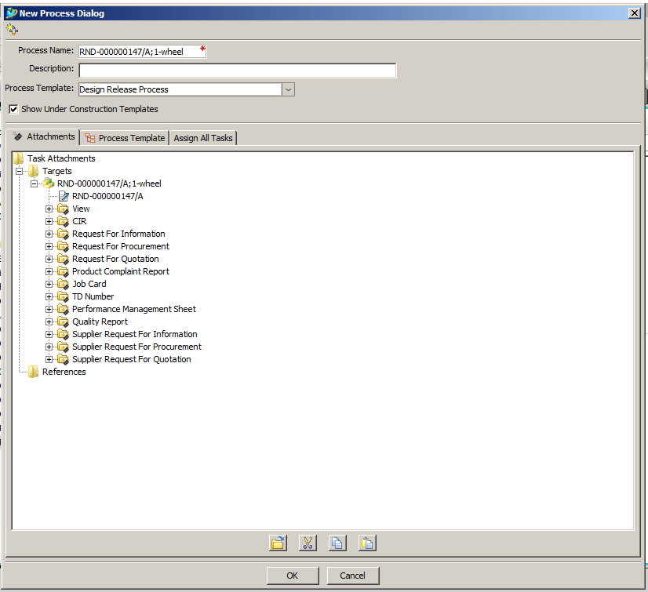

Click on **Assign All Tasks** and assign users for every particular task.

Select Users from Resources tab and assign user from organization tree.

For e.g.: In Design Review task select Users under it and select Jijesh user from Design Lead role.

After every user selection click on Add.

After assigning of users for tasks click on OK.

Workflow process will initiate.

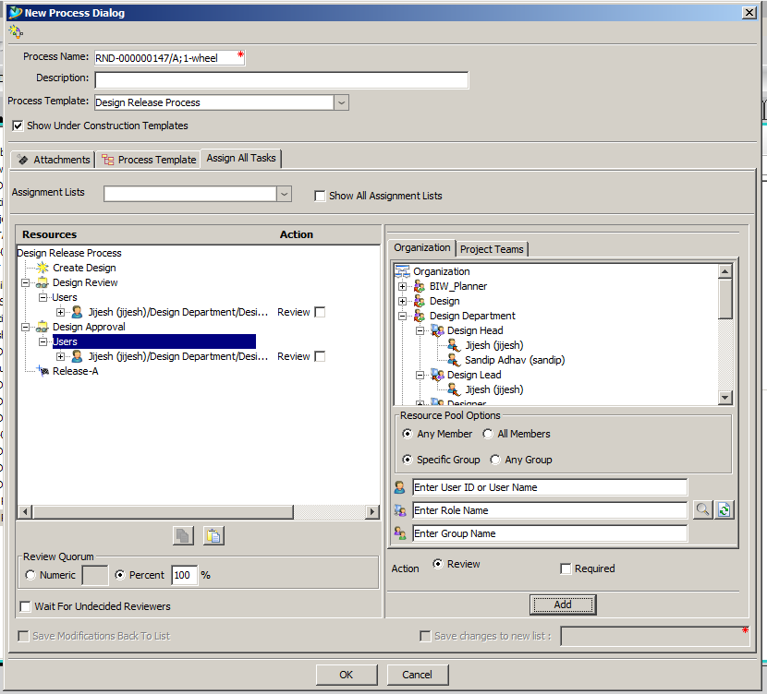

After initialization of process on revision icon will appear ahead of revision.

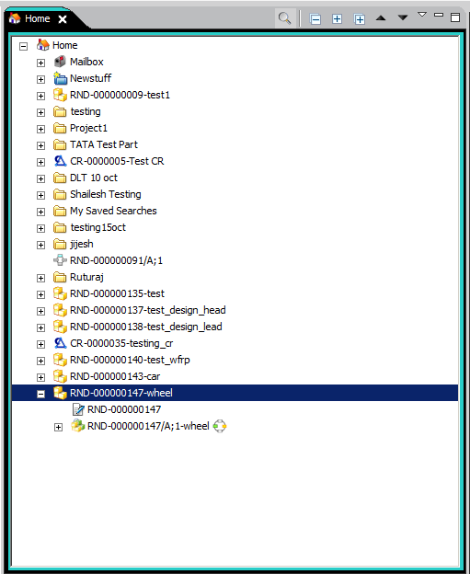

Right click revision -> SendTo -> Workflow Viewer

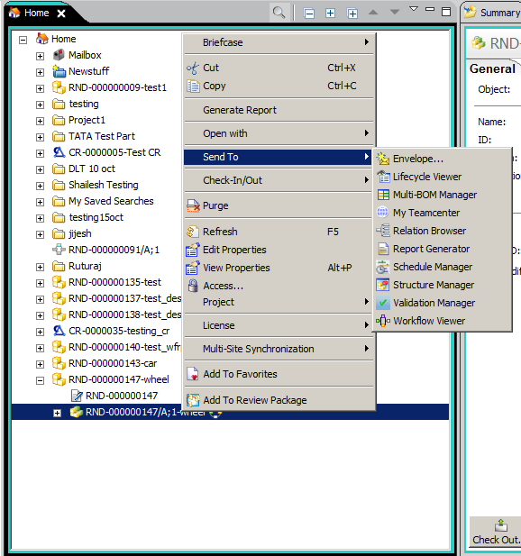

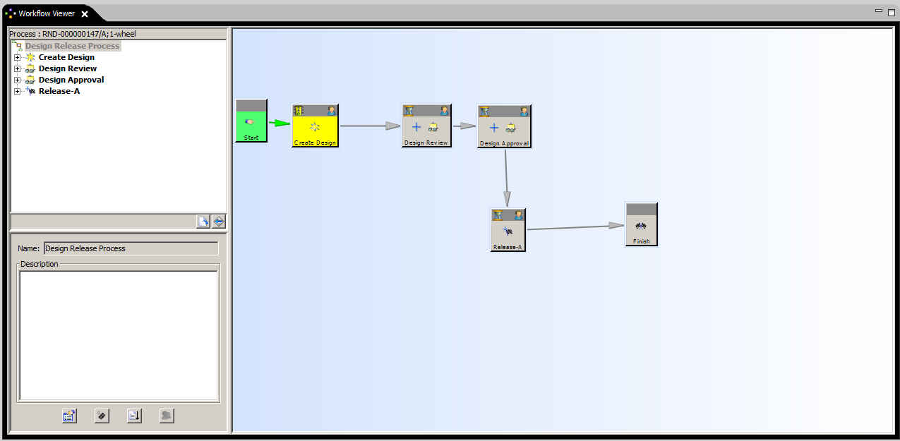

Select Do Task and perform complete action comments are optional.

Click OK.

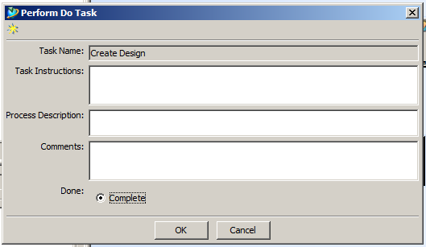

Review task is assigned to particular user.

The assigned user will find tasks assigned to him in my worklist.

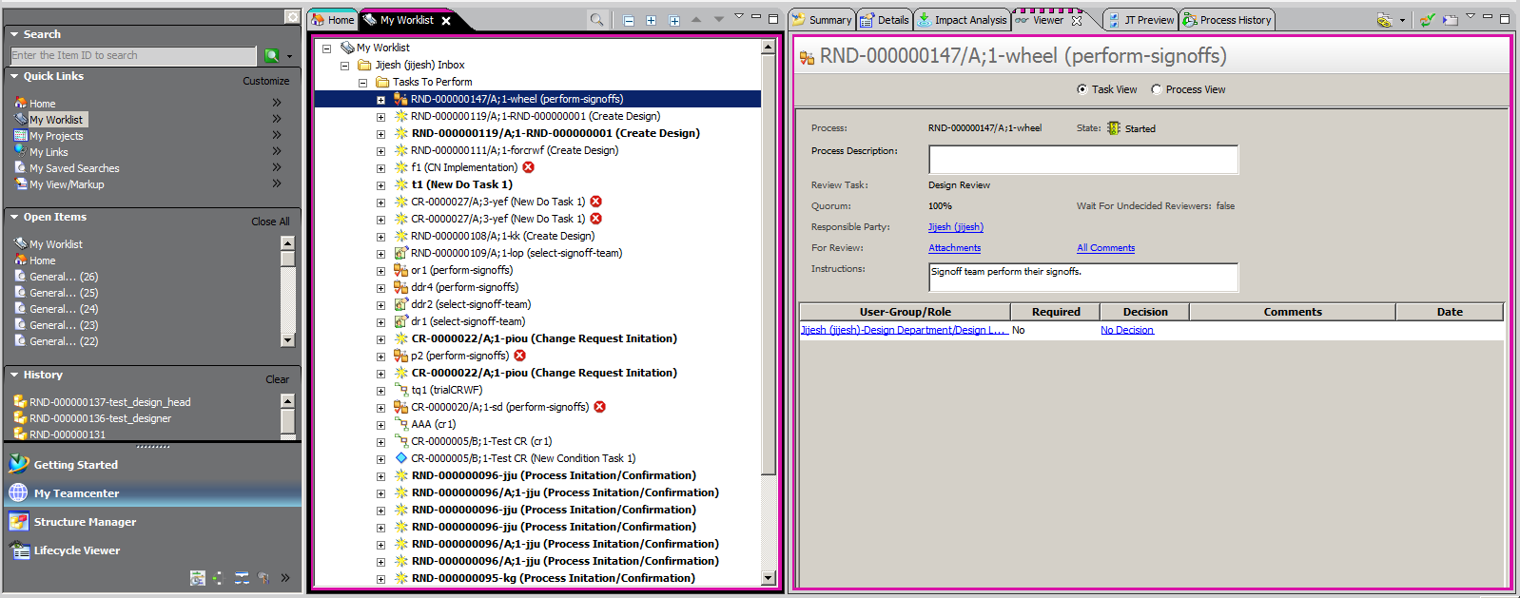

Click on No Decision

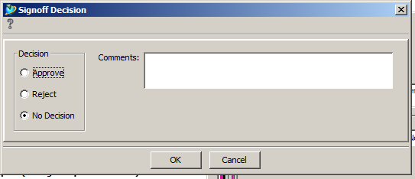

Give Signoff Decision (Comments are mandatory for Approve and Reject decision)

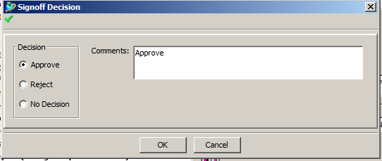

Workflow is at second review task it is assigned to particular user.

The assigned user will find tasks assigned to him in my worklist.

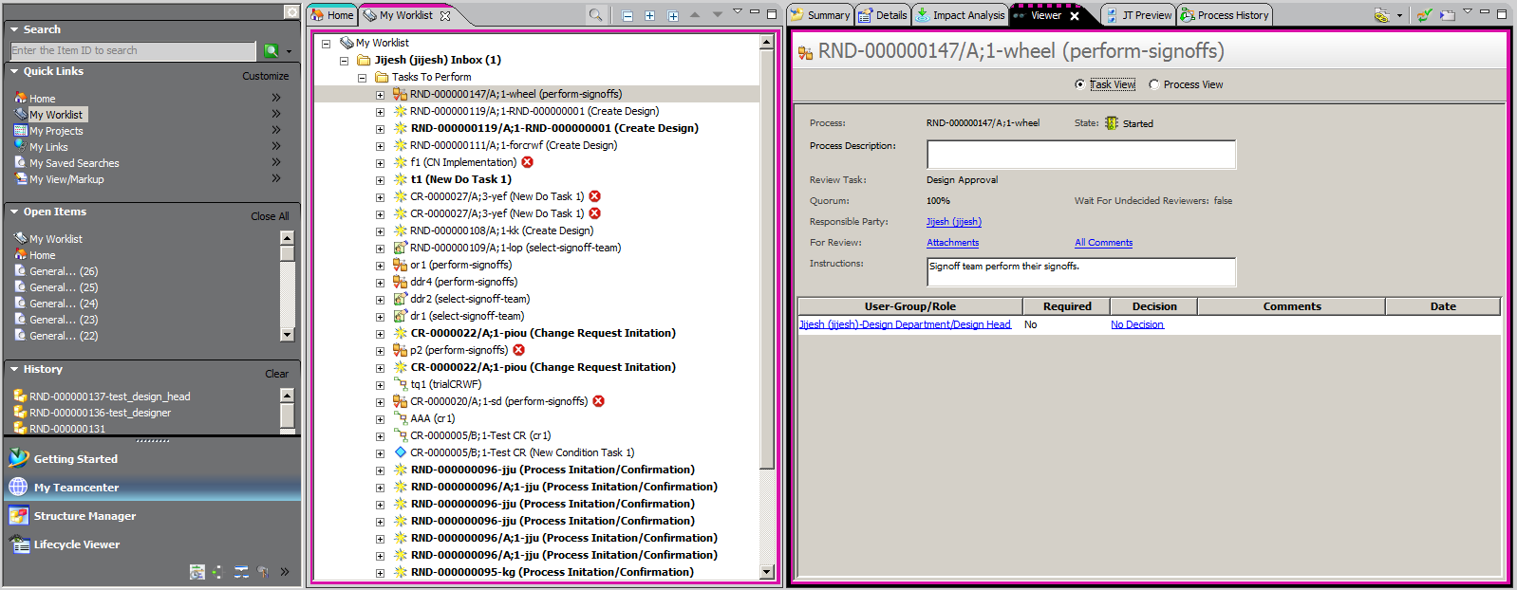

Click on No Decision.

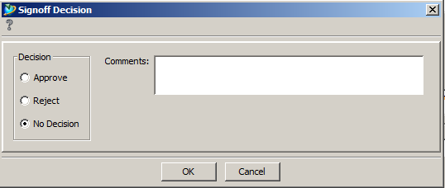

Select decision (Comments are mandatory for Approve and Reject decision)

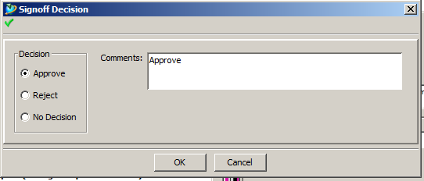

Flag will appear on revision so now process is completed and process status task is applied on it.

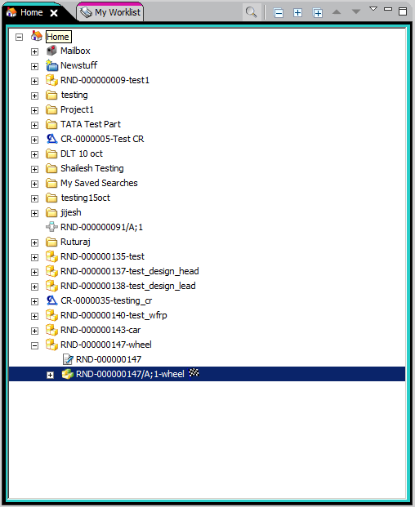

PART OBSOLUTE WORKFLOW PROCESS:

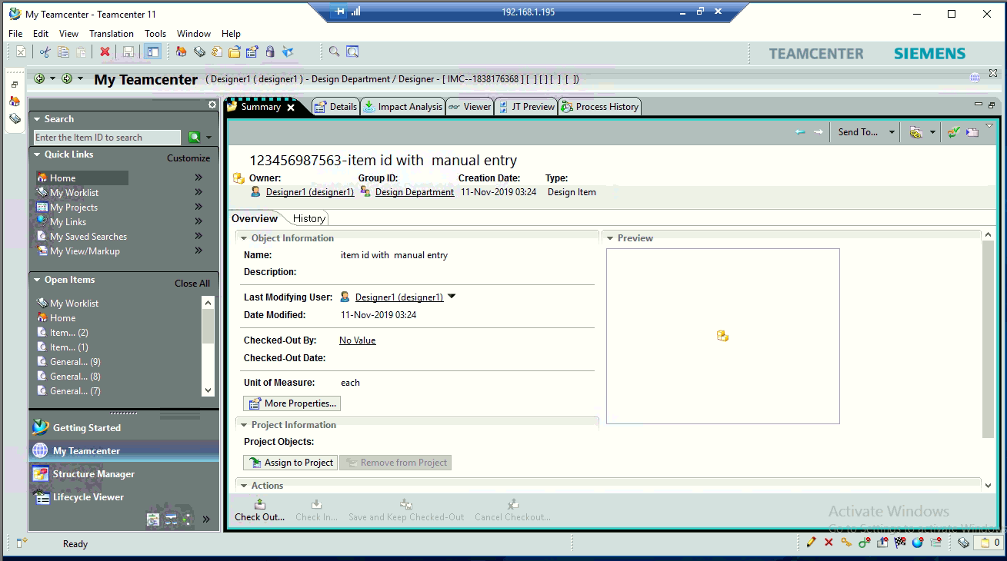

Select the item you want to make it obsolute from teamcenter.

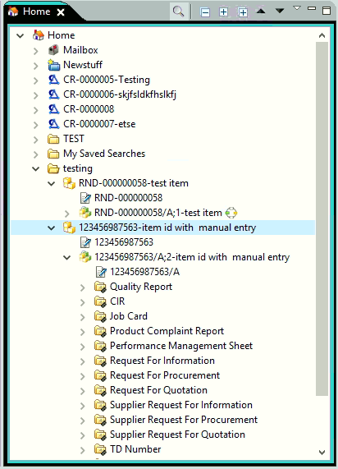

Attach the work flow process by selecting the workflow template.

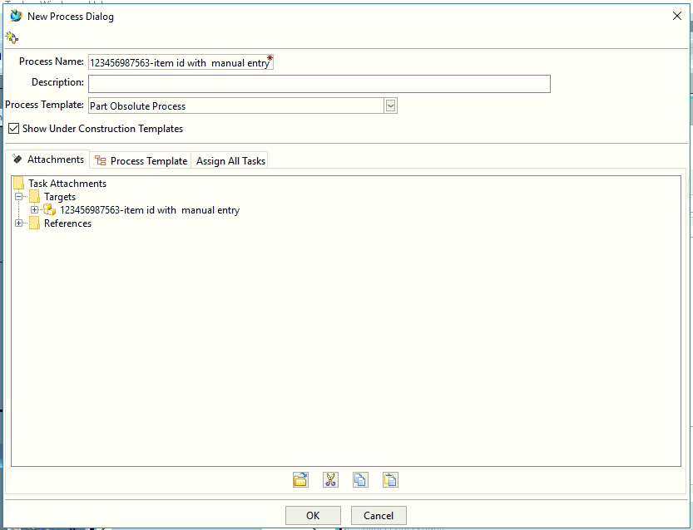

Assign the user participants to the workflow.

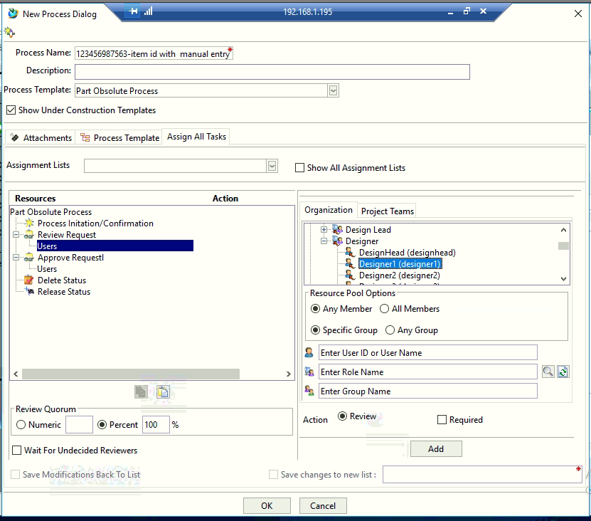

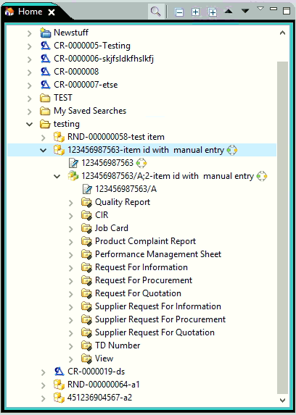

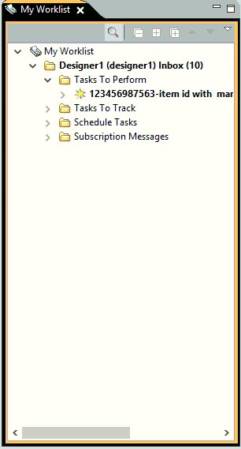

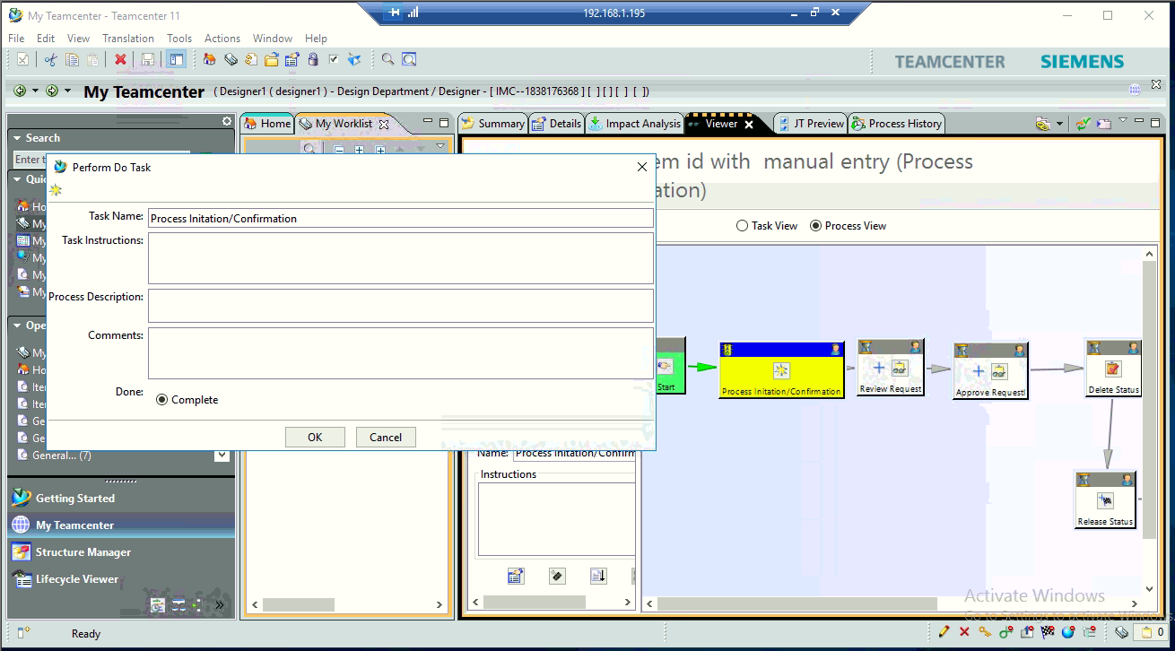

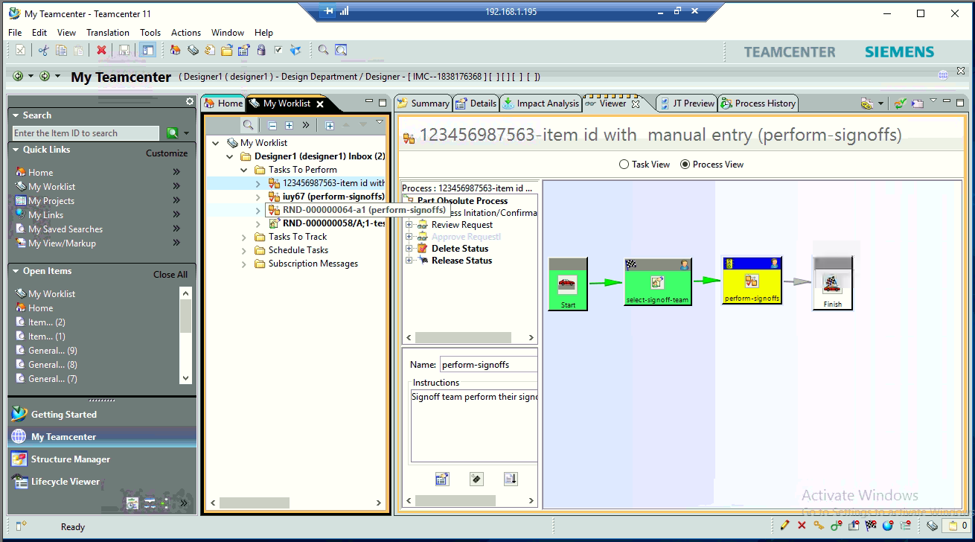

On completion of process item along with all the revisions will be released.

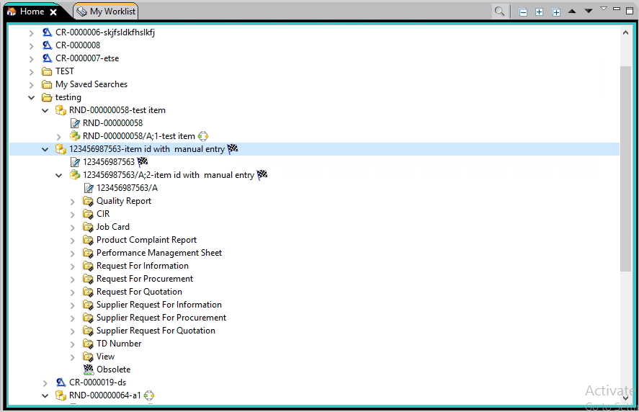

Quick Release Design Process:

**Note: To be initiated by design head only.

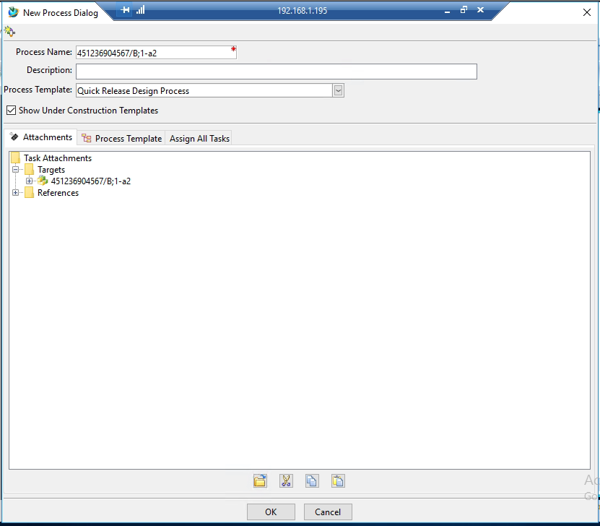

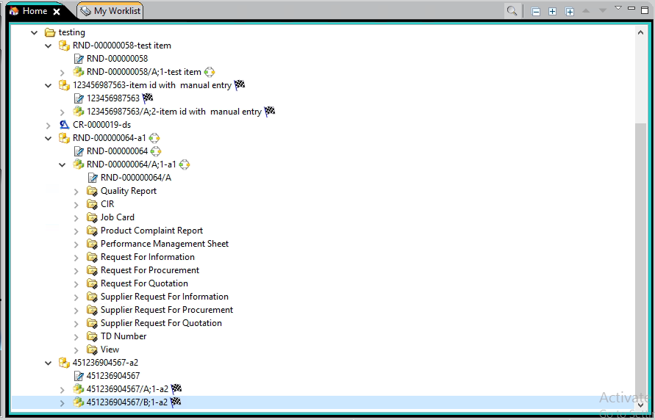

Steps to assign participants to process assignment list.

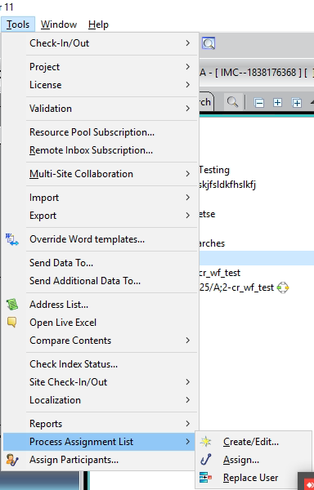

Select the users to be assigned to the process.

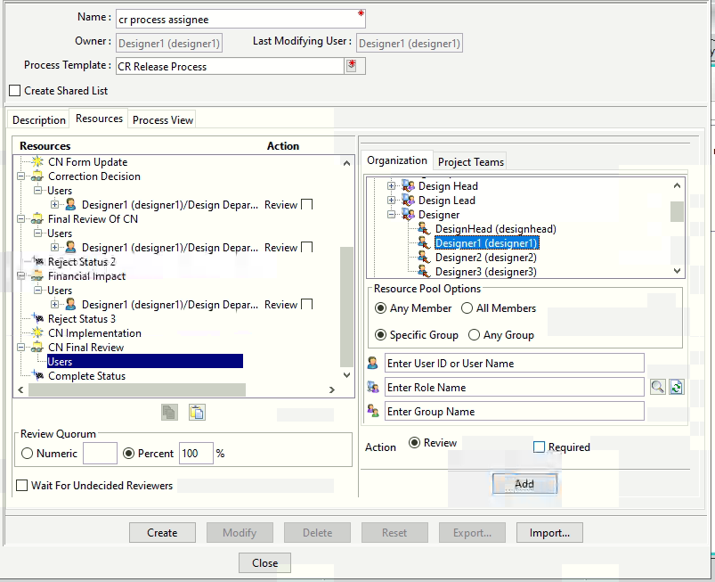

CR Release process:

Select the CR Item revision and attach the workflow to the process.

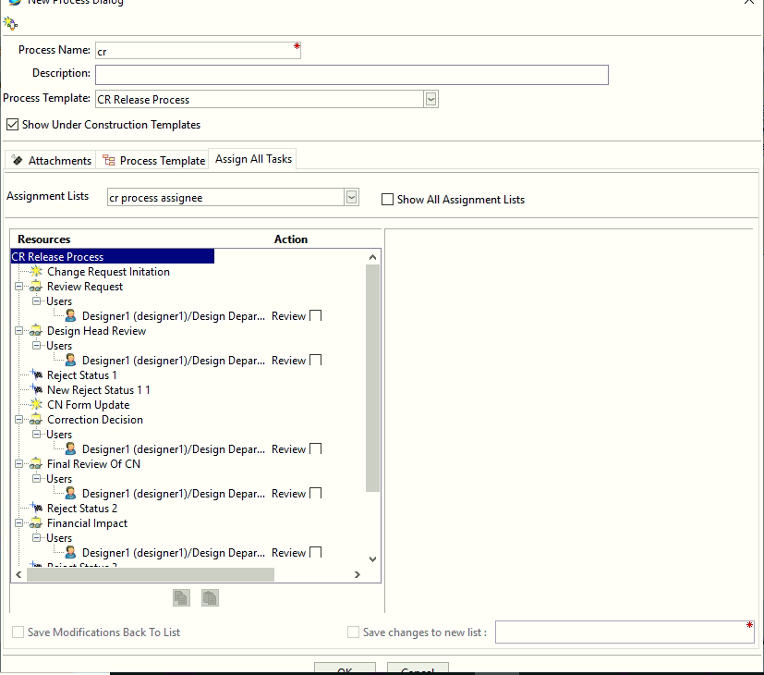

Task assigned can be checked in the worklist of the user.

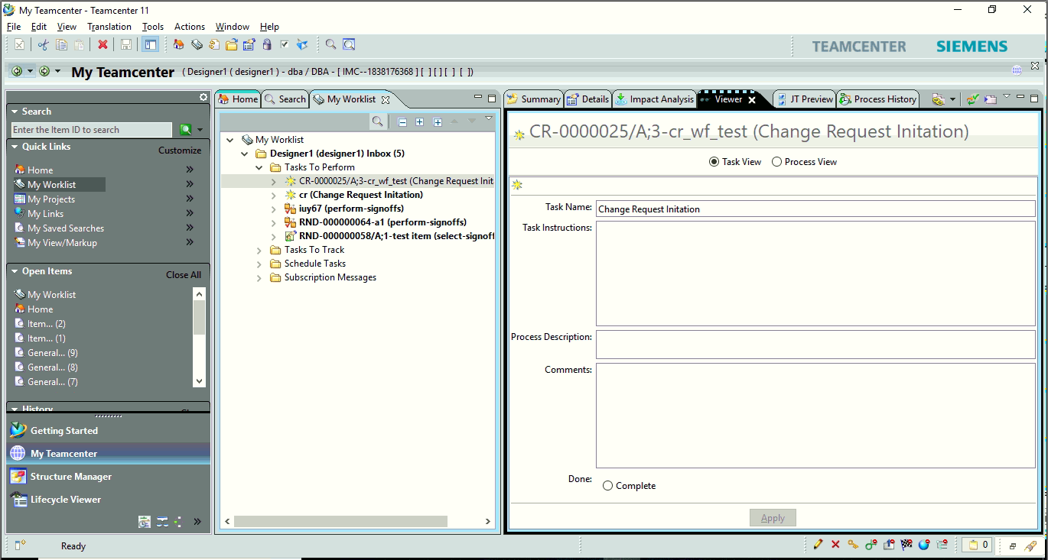

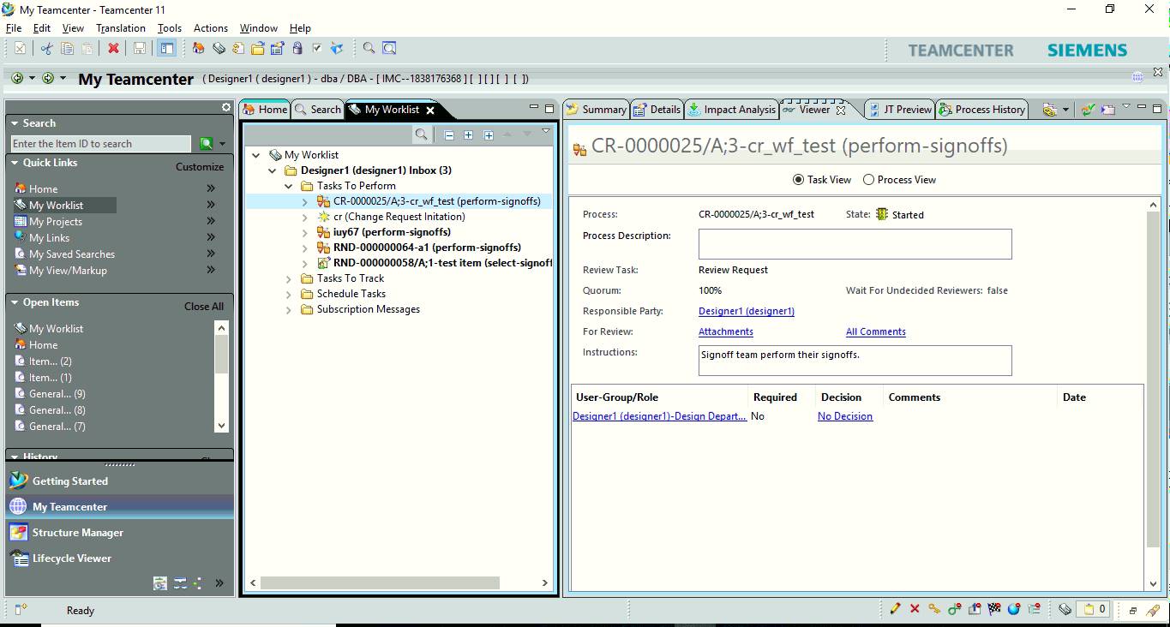

Comments are mandatory to the workflow review task.

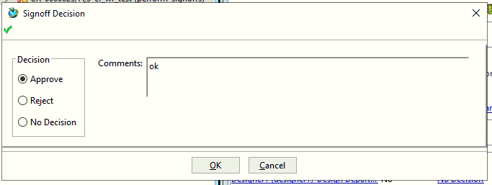

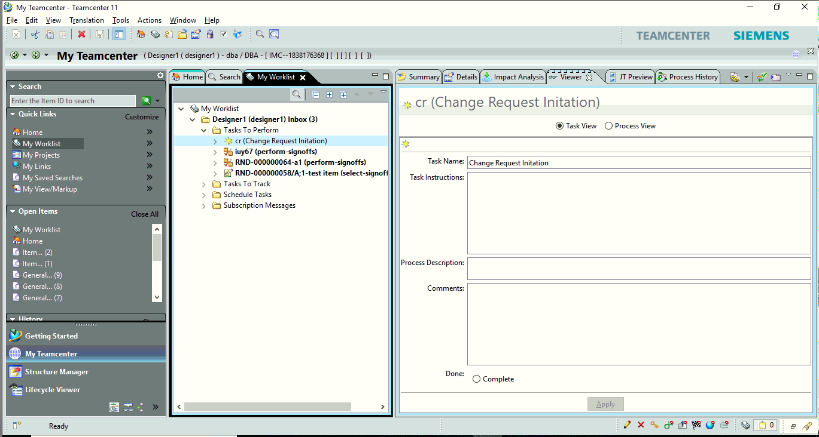

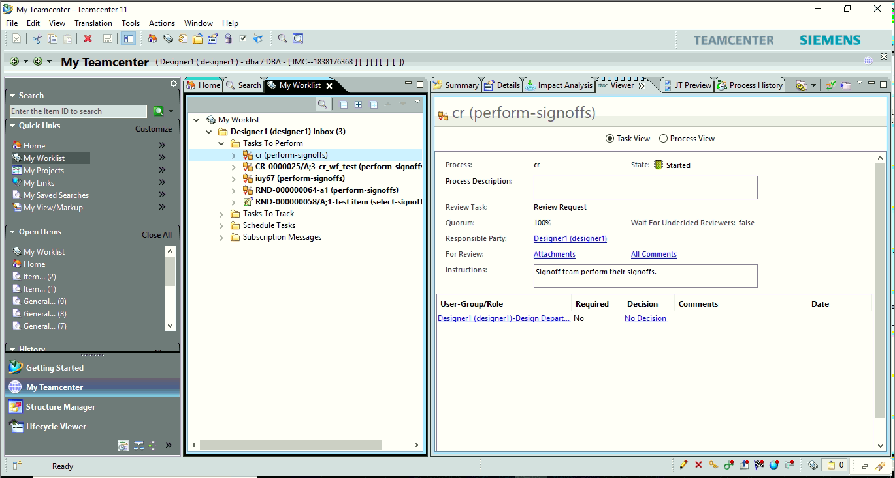

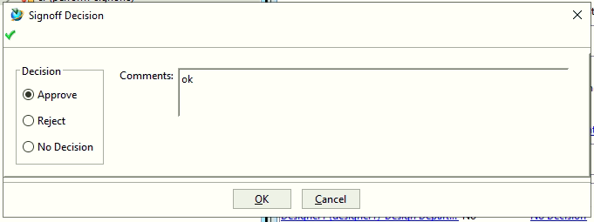

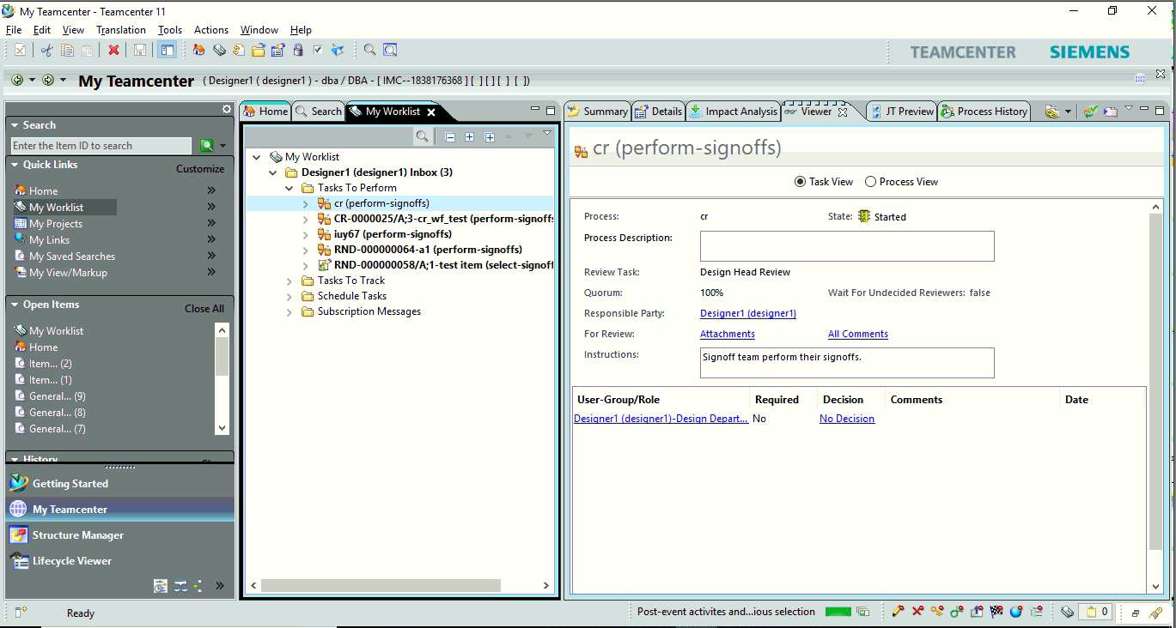

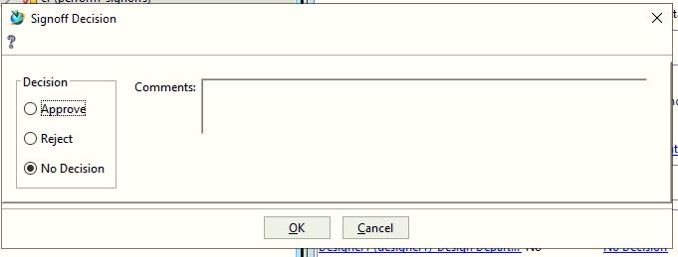

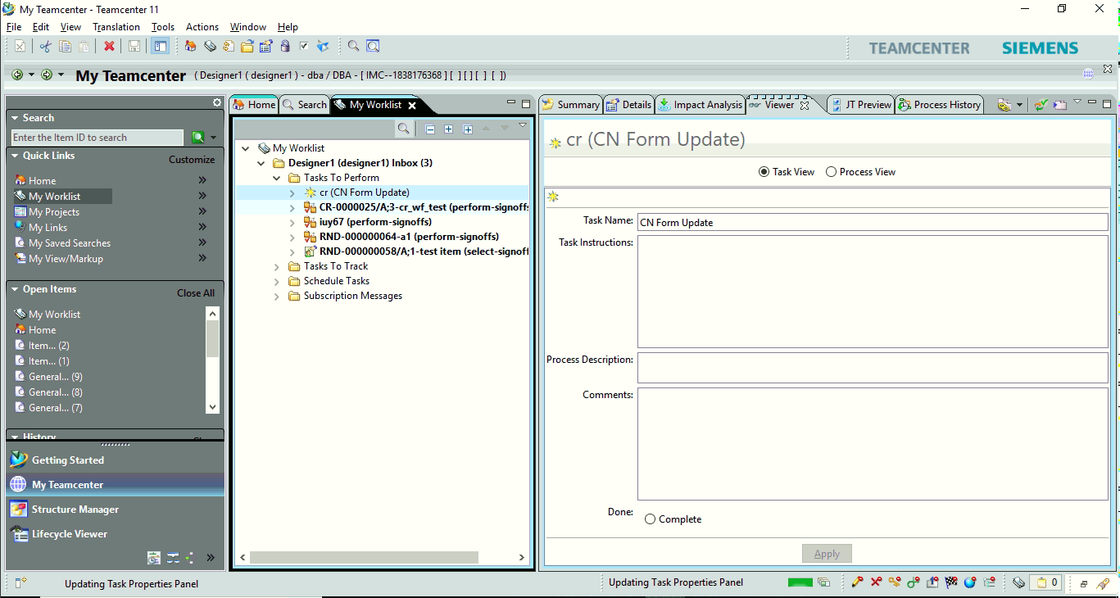

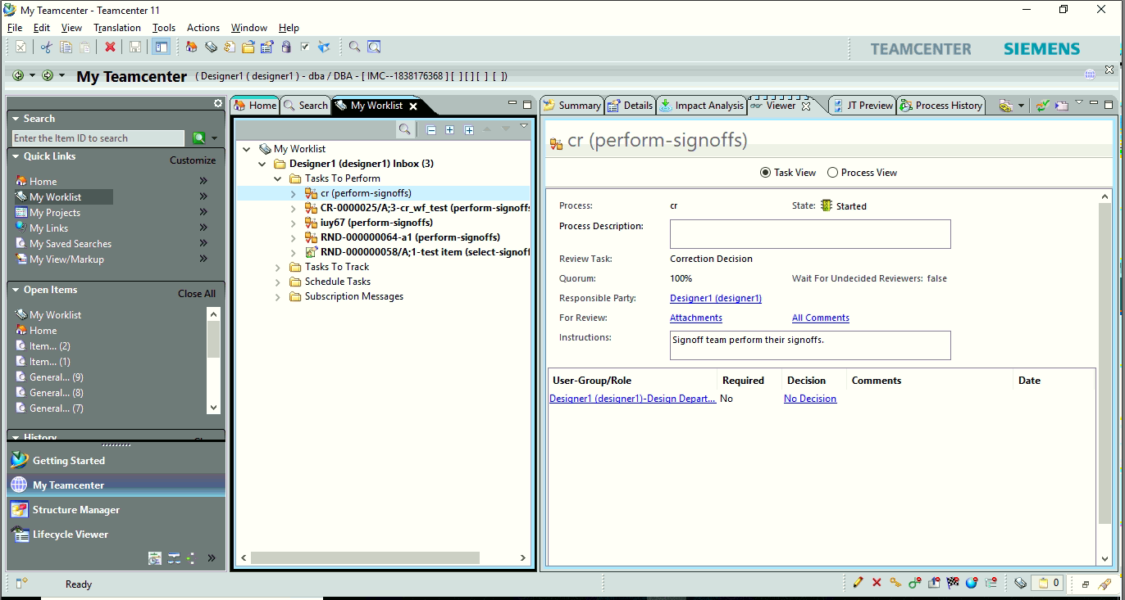



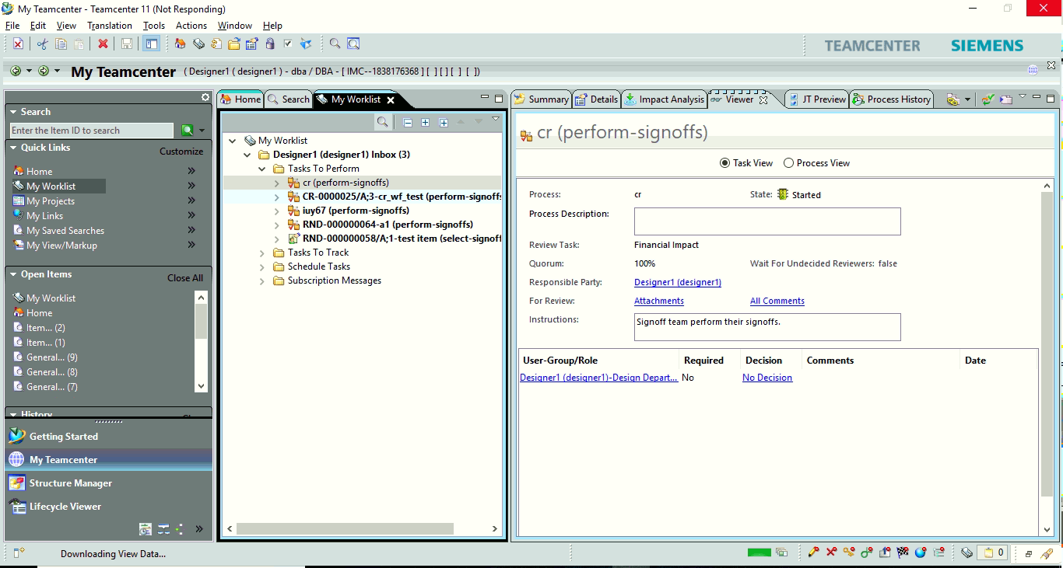

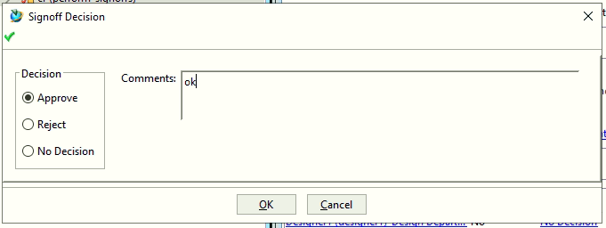

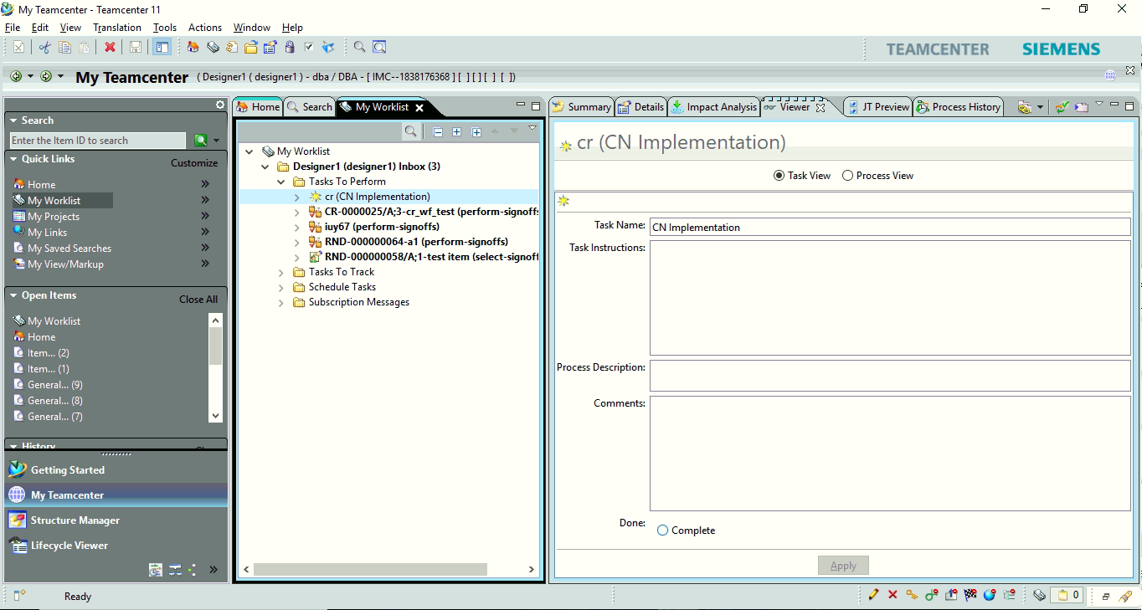

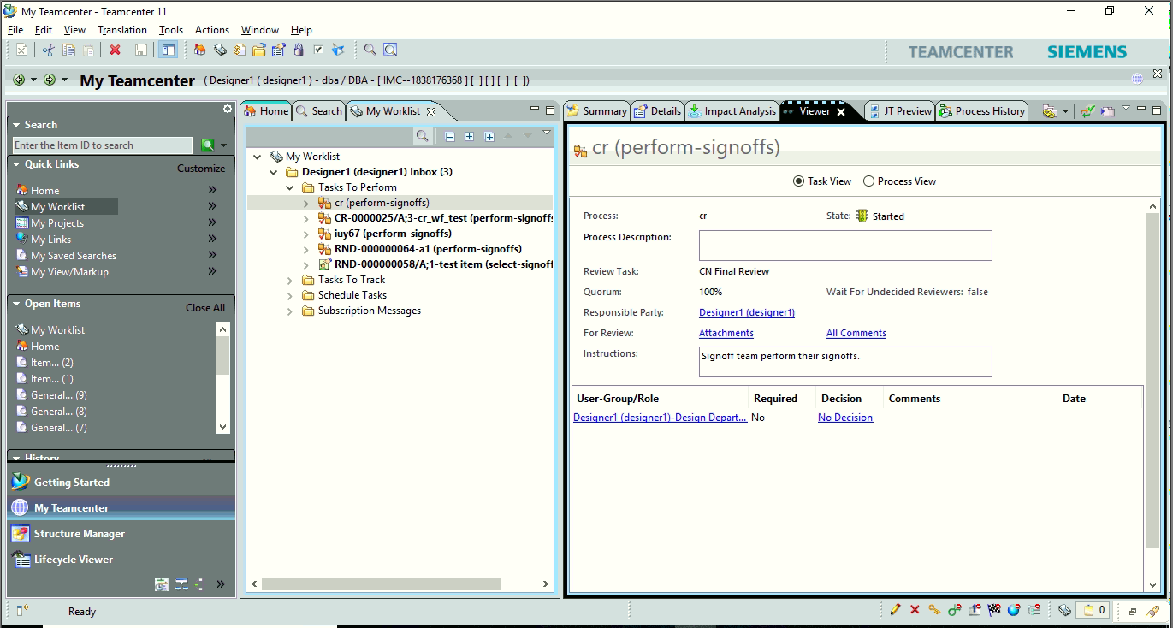

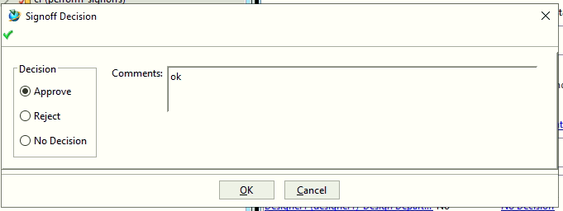

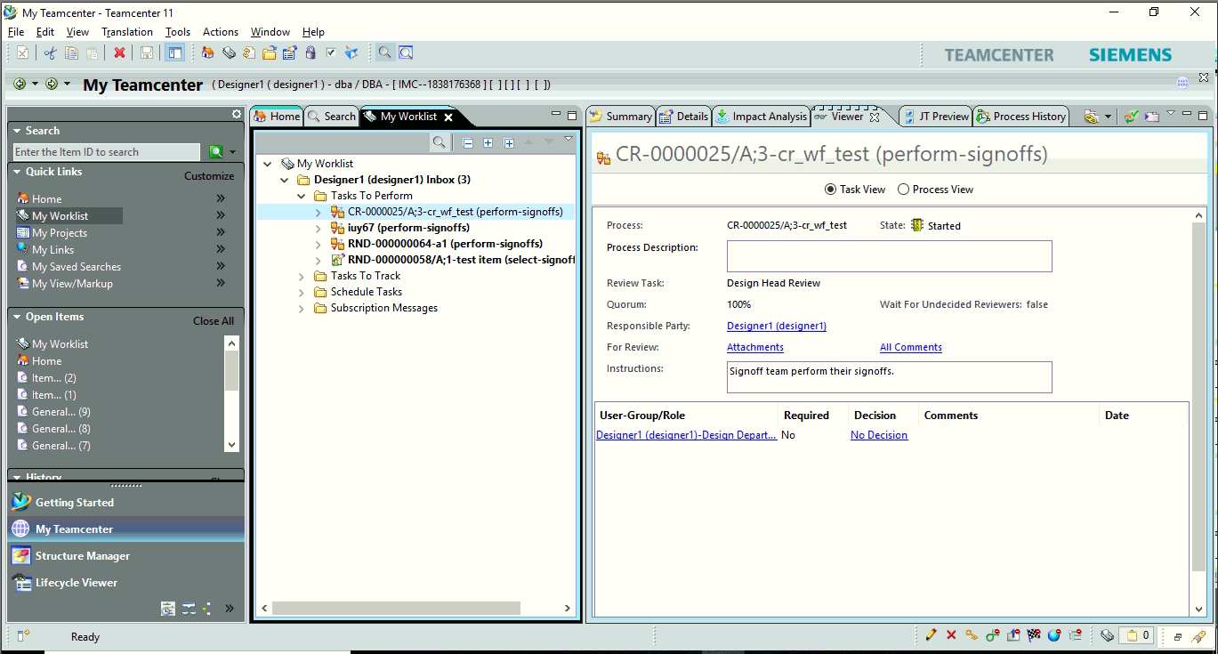

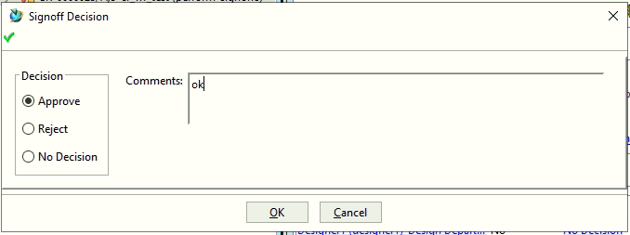

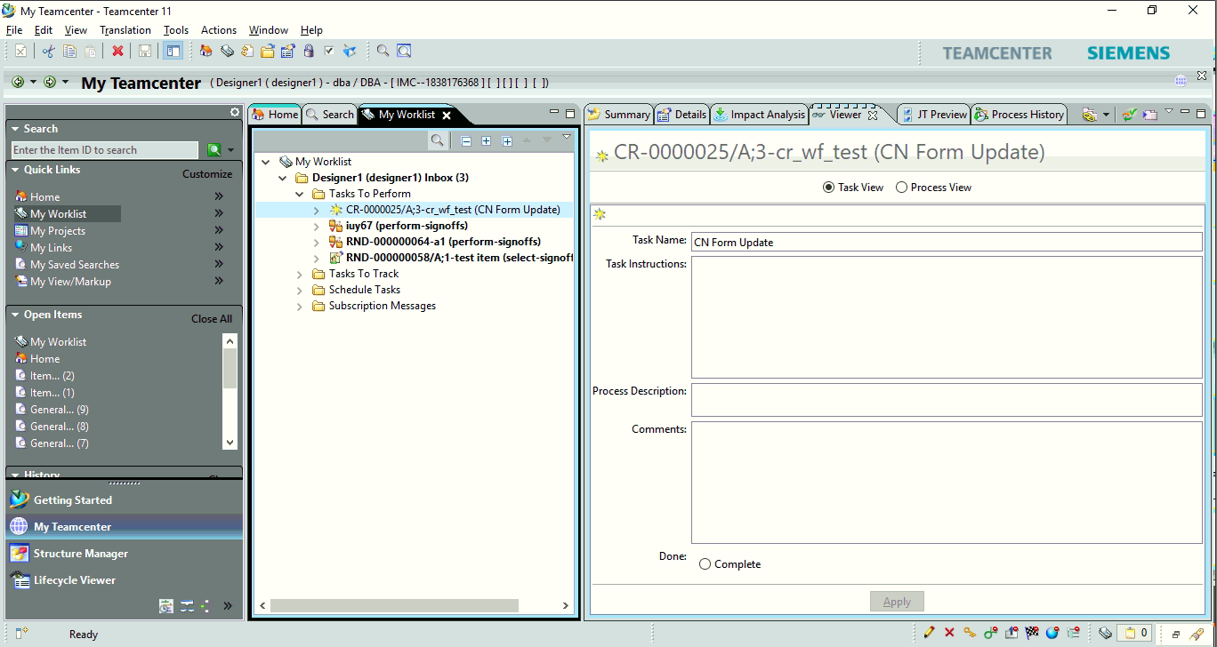

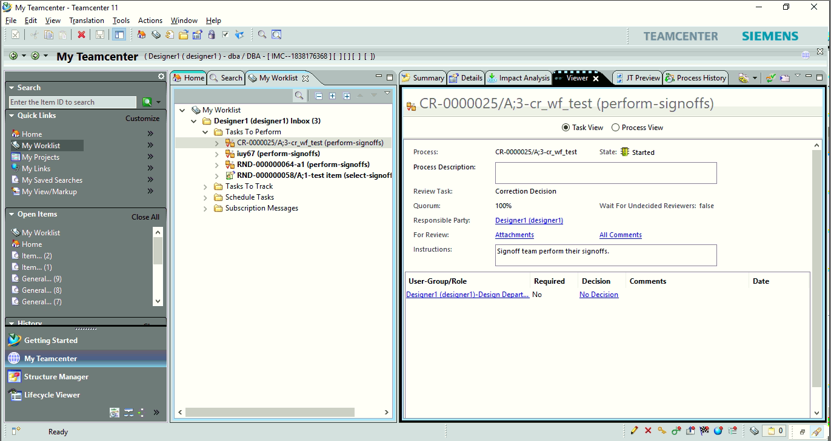



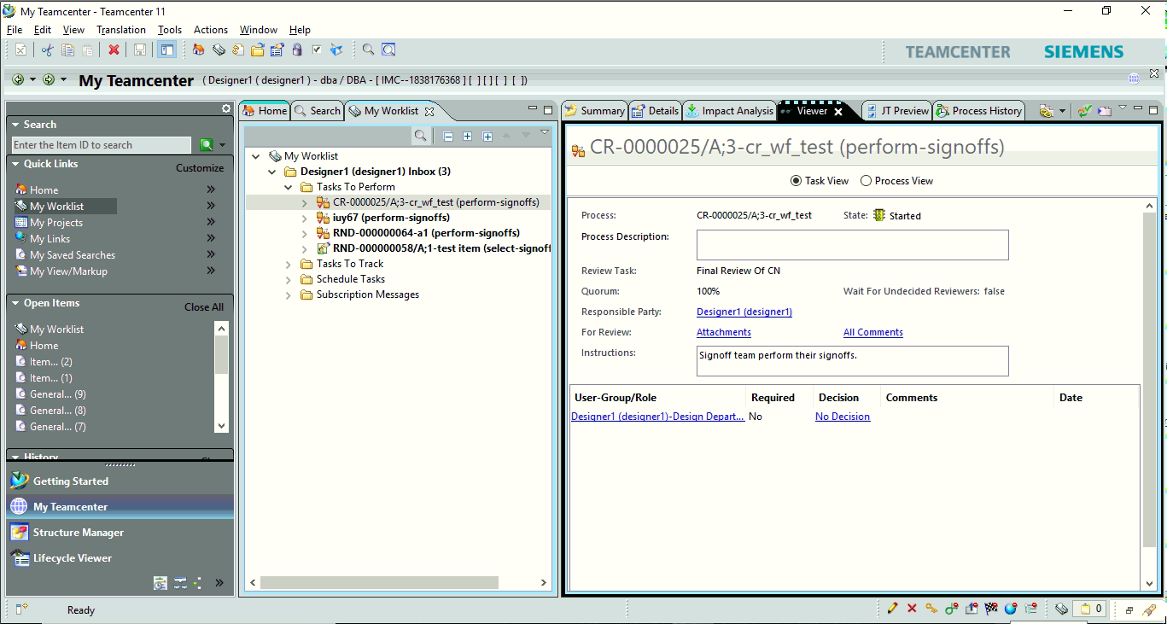



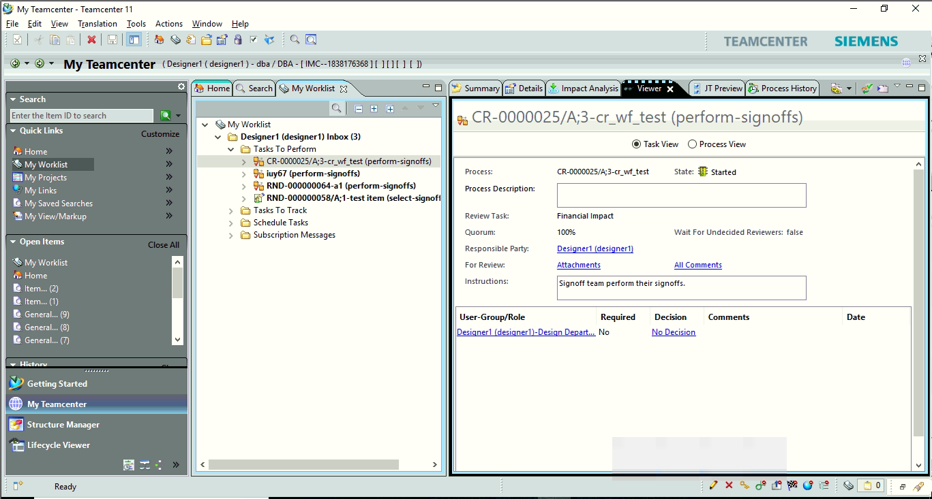



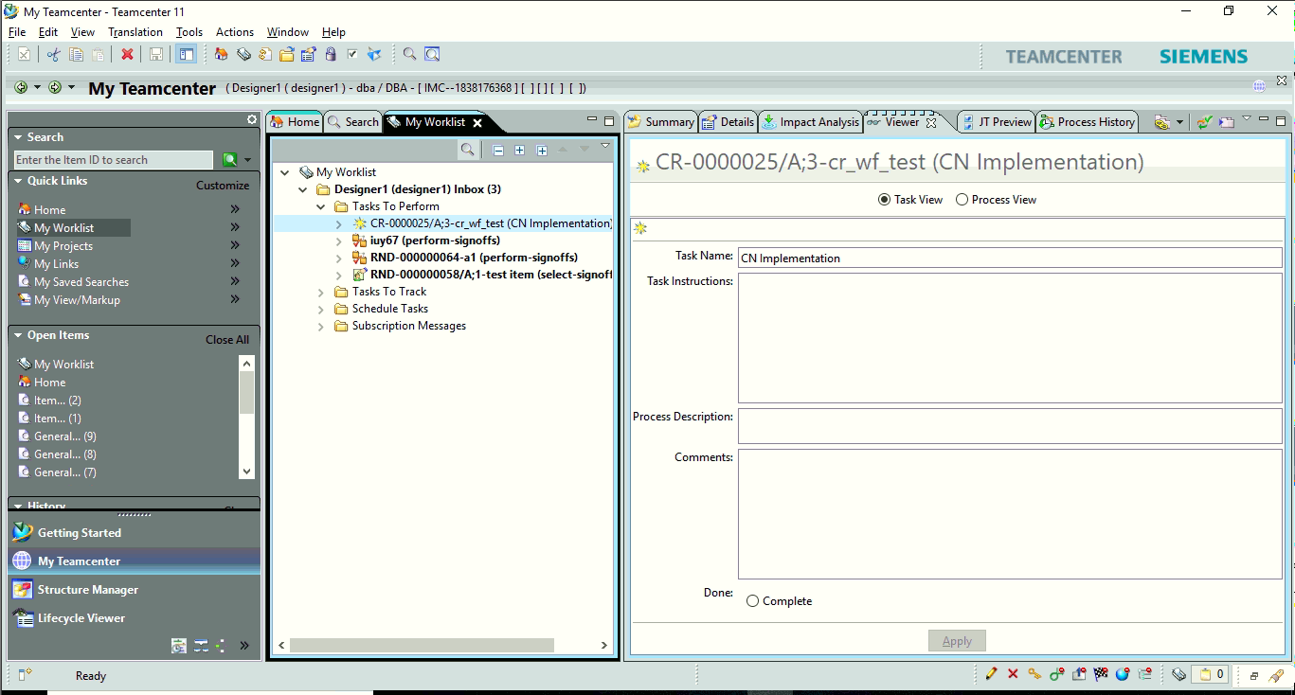

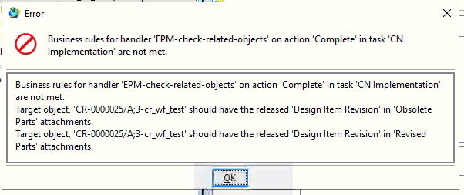

Design items are required to be pasted in the Revised parts and Obsolute part pseudo folders.

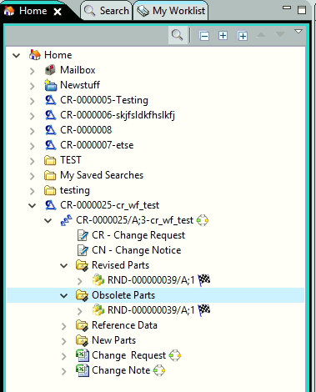

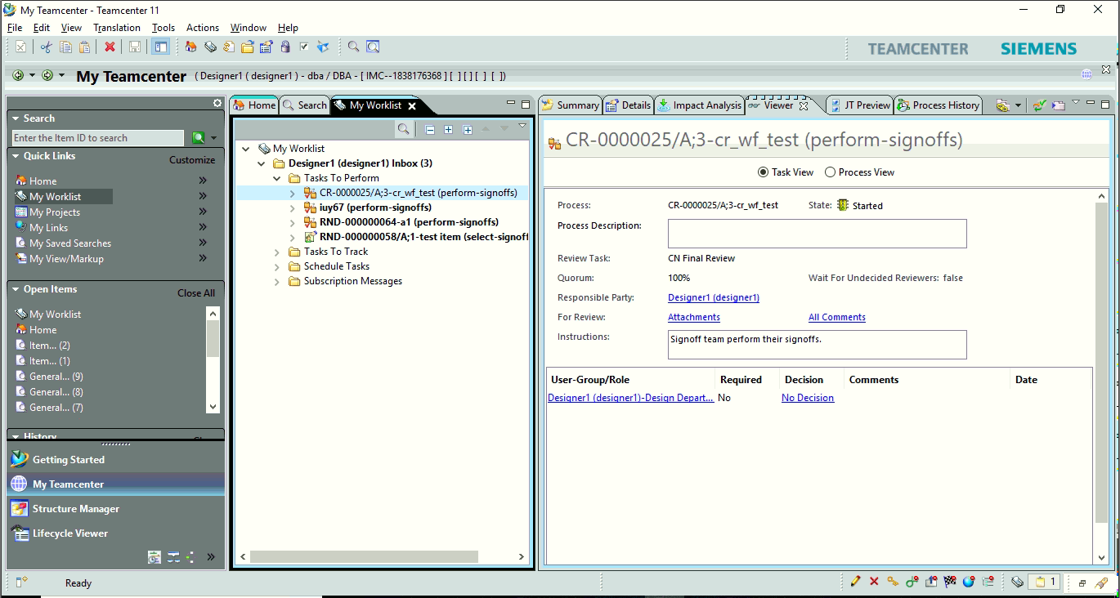



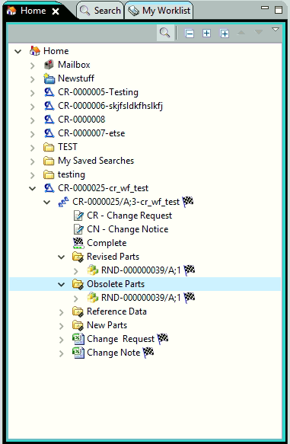

**Saving Solid Edge part in Teamcenter**

Open Solid Edge 2019.

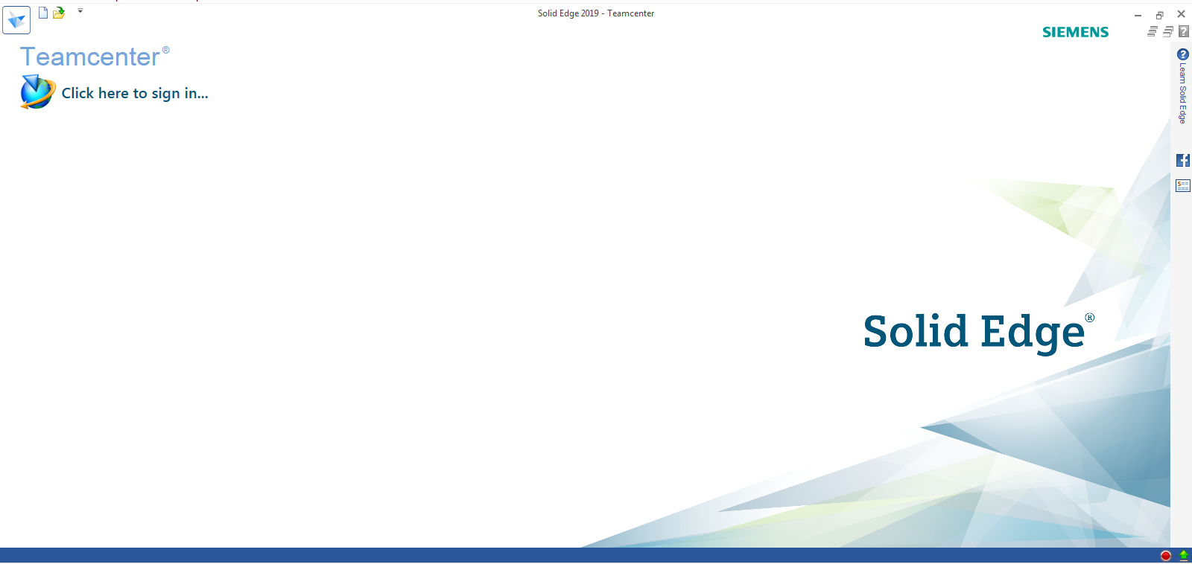

Select **Click here to sign in…**

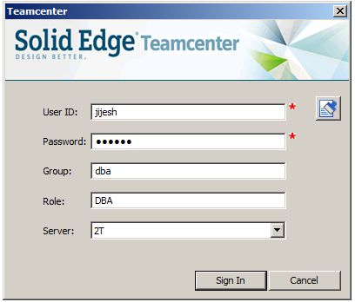

Login with user credentials.

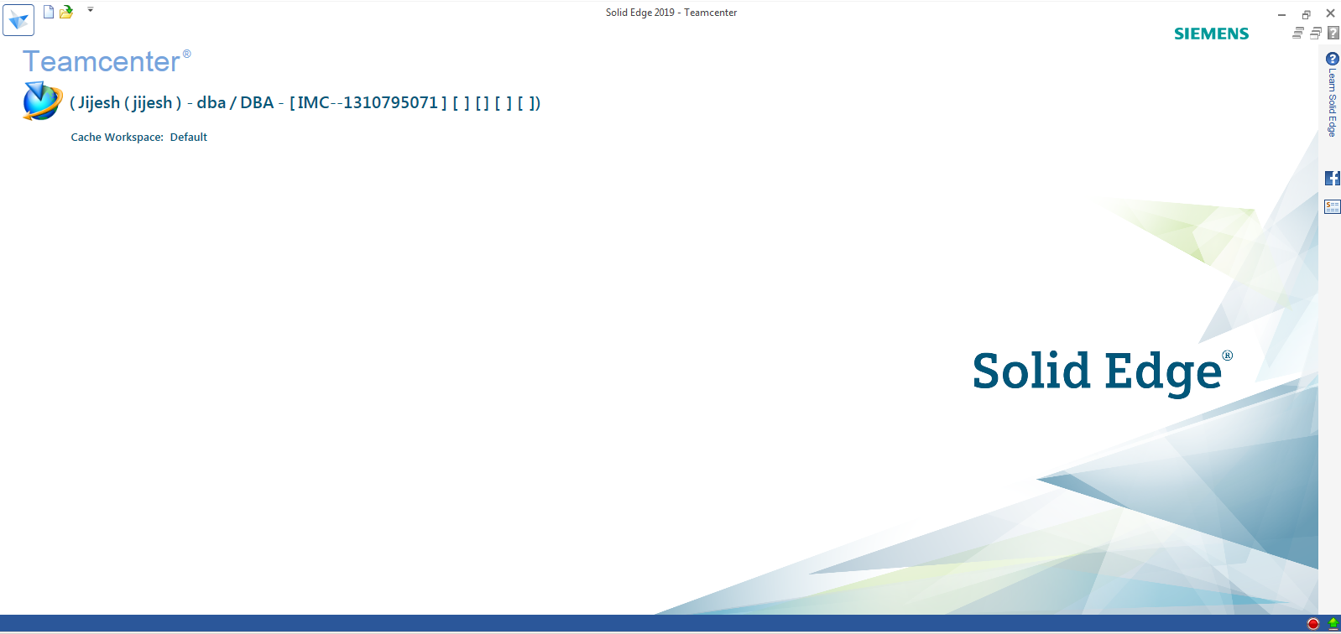

Click **New** (Ctrl+N)

Select **ISO Metric.**

Select **iso metric part.par.**

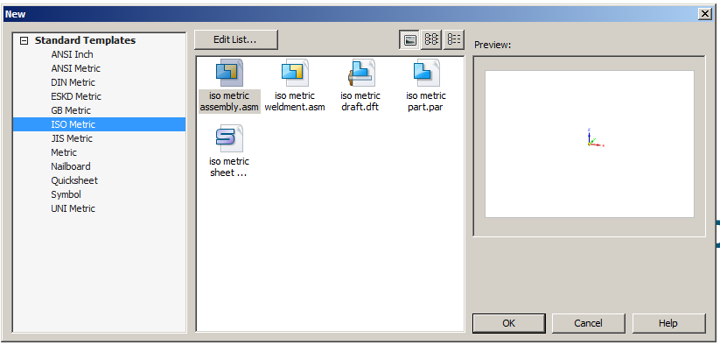

Create part, apply material and save (ctrl+S).

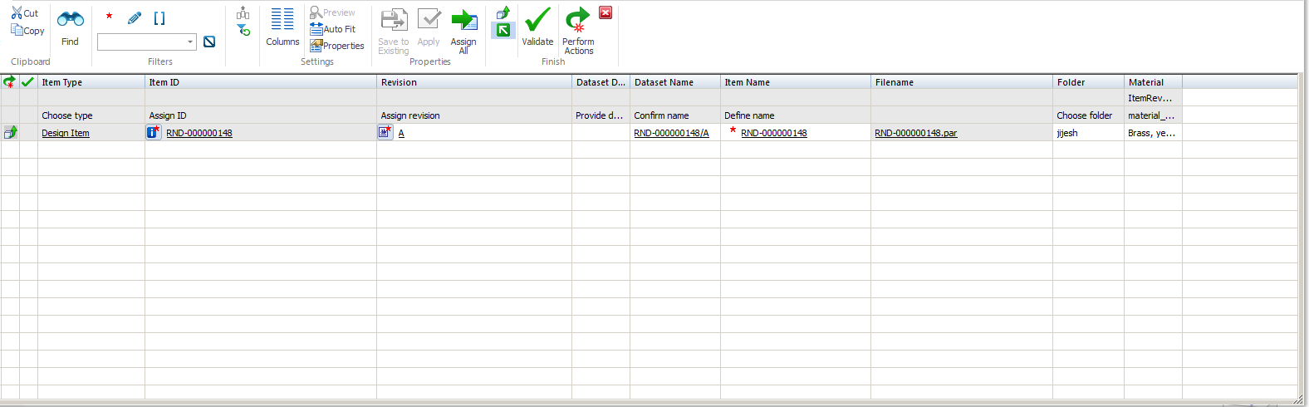

Choose type select **Design Item.**

Click **Assign All.**

Click **Validate**.

Click **Perform Actions.**

Create other parts follow same steps.

Select new (Ctrl+N)

Select **iso metric assembly.asm**

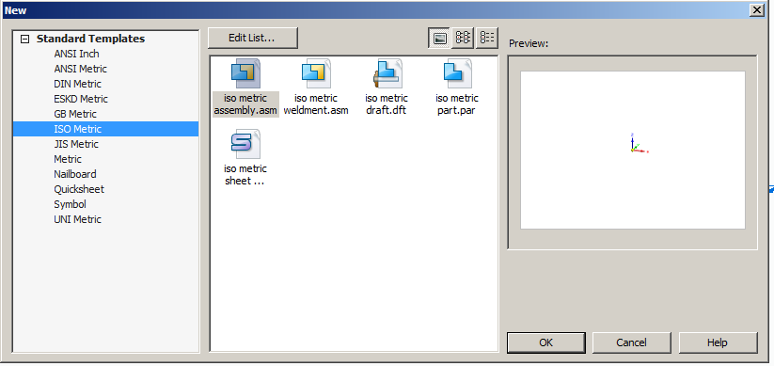

**Note: While creating assembly you have to save it first to Teamcenter**

Click save (Ctrl+S)

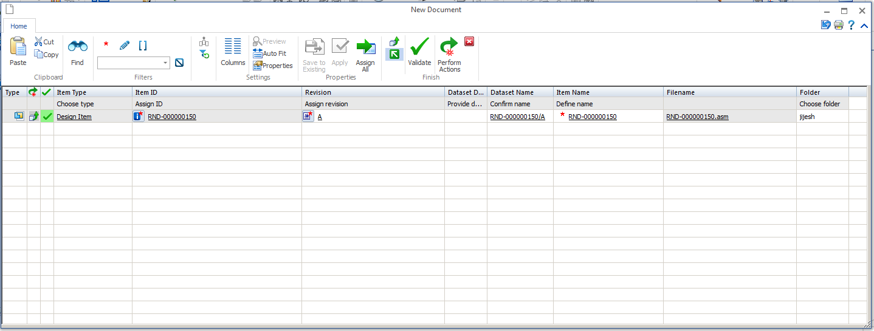

Choose type select **Design Item.**

Click **Assign All.**

Click **Validate.**

Click **Perform Actions.**

Click **Insert Components.**

Search for part you want to add.

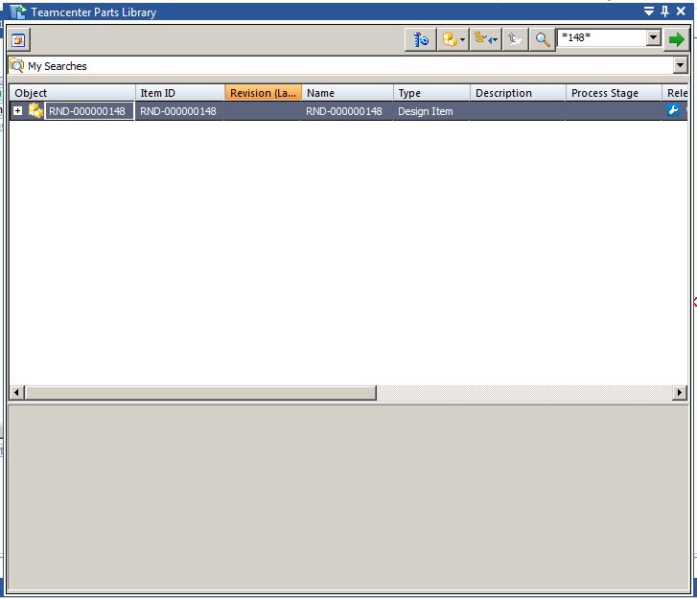

Double click on it and it will get added to assembly.

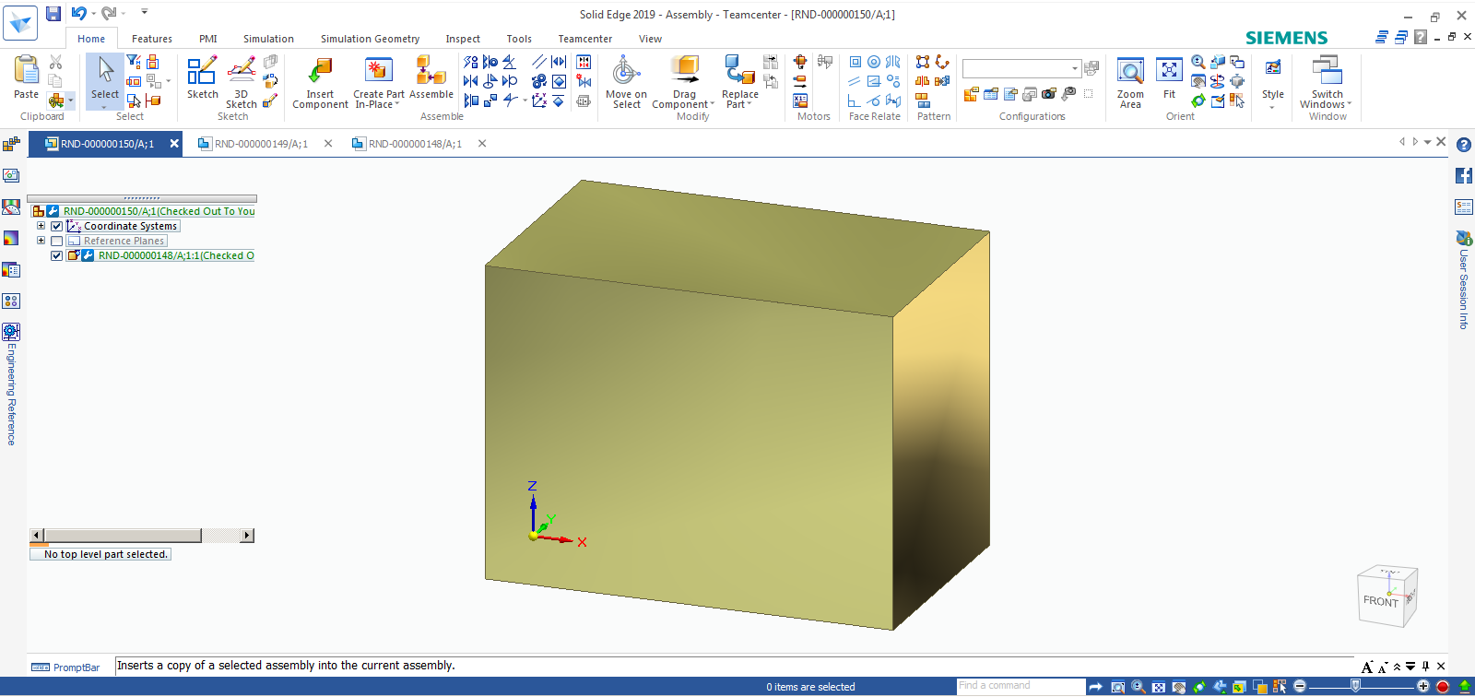

Add another part in assembly.

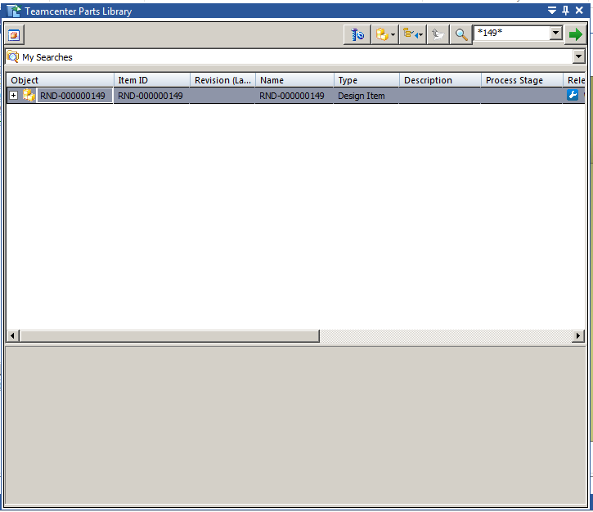

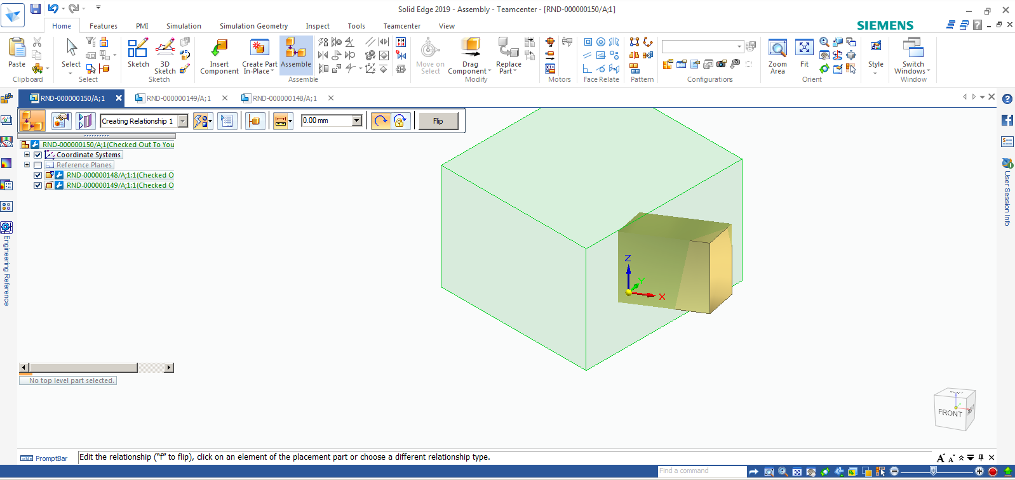

Save assembly again Ctrl+S.

Click new.

Select **iso metric draft.dft**

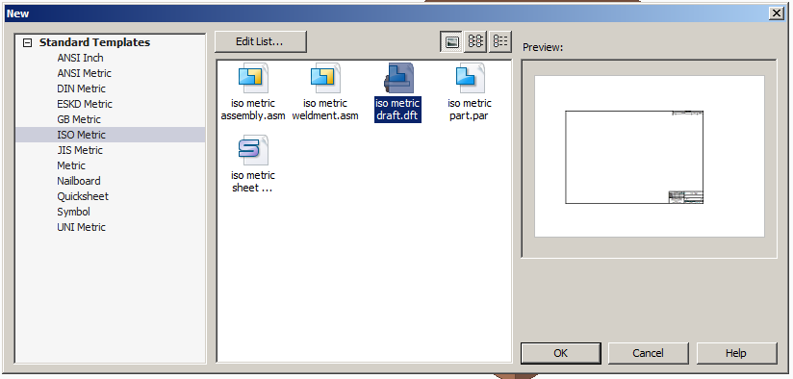

Click on View Wizard.

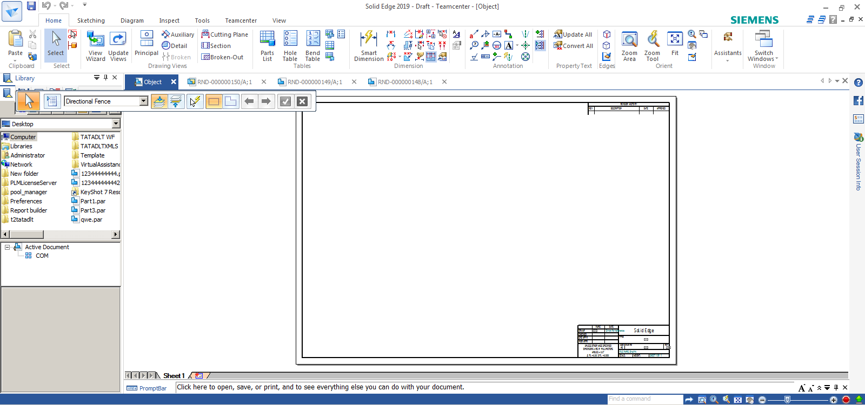

Search or select from folder and select open.

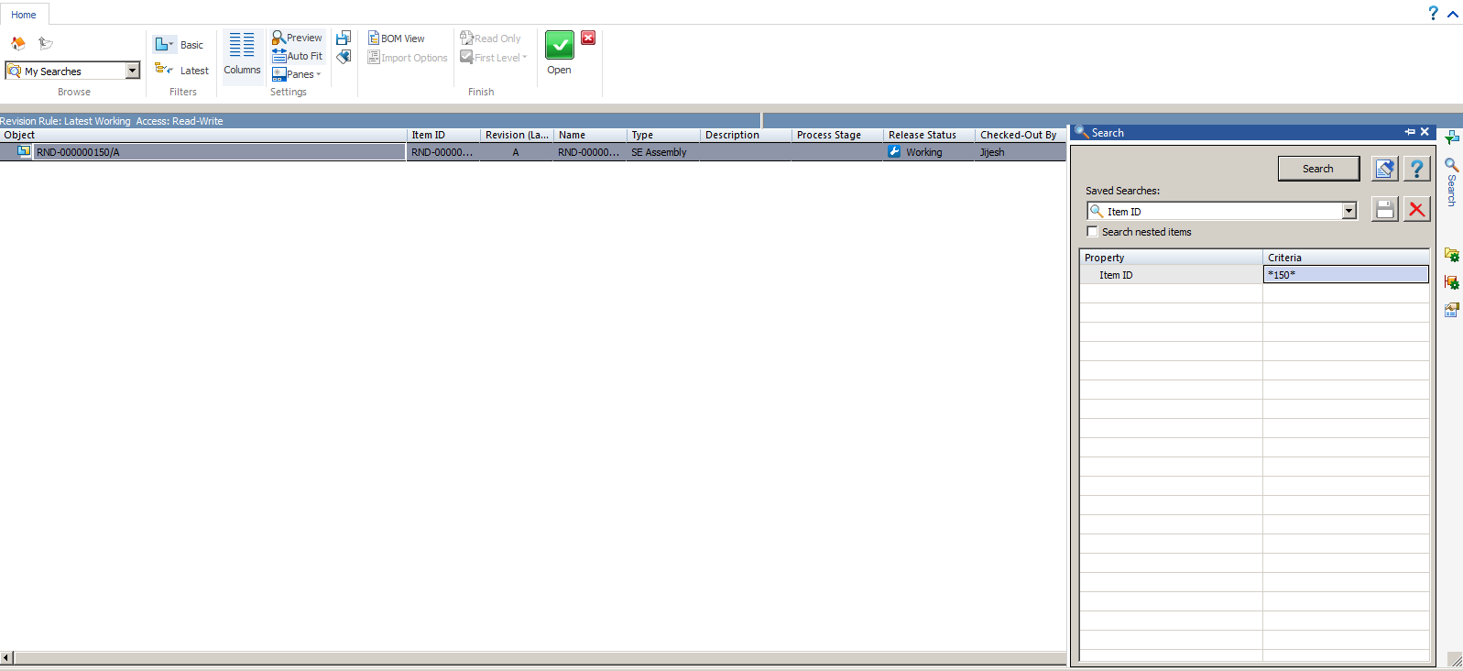

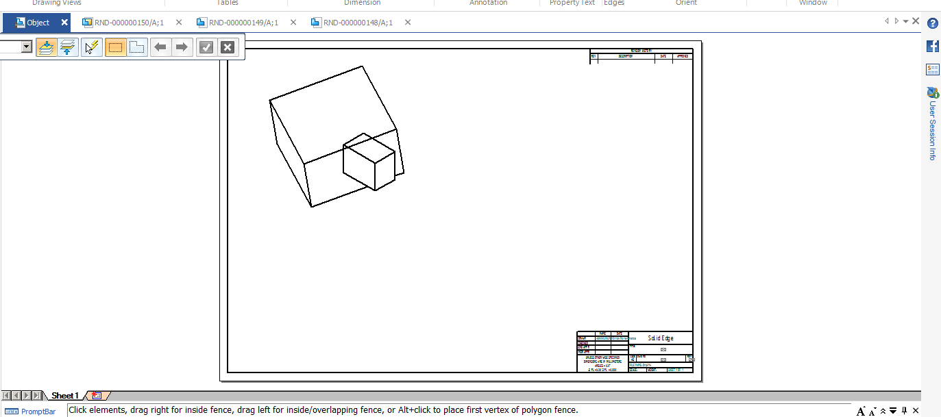

Click on save (Ctrl+S).

Click Assign All.

Click Validate.

Click Perform Actions

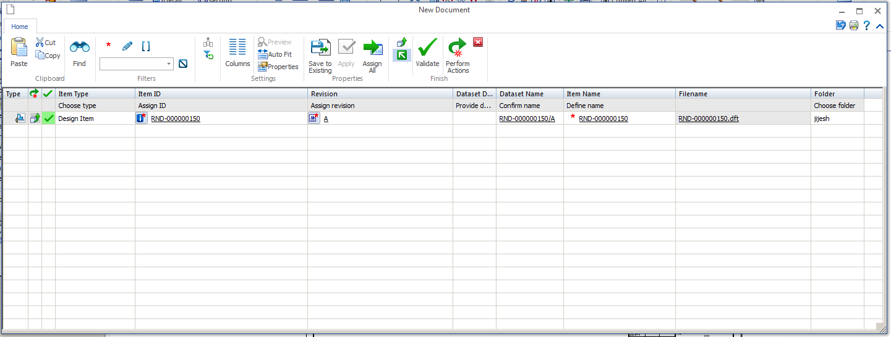

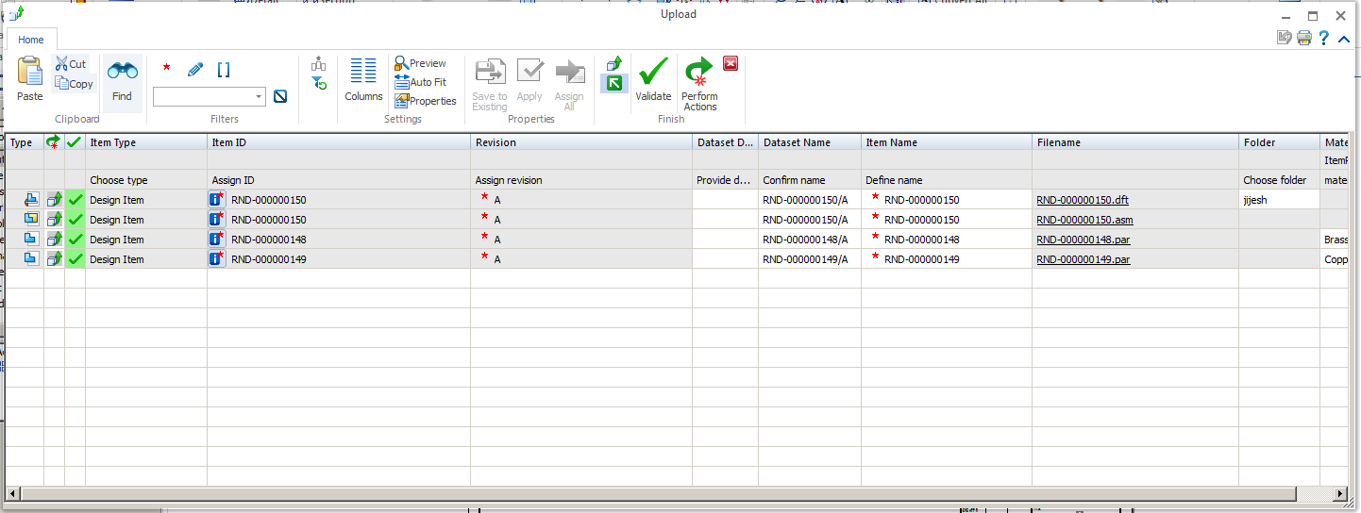

Click validate.

Click Perform Actions.

Working offline in solid edge

Go to Manage -> Cache Assistant

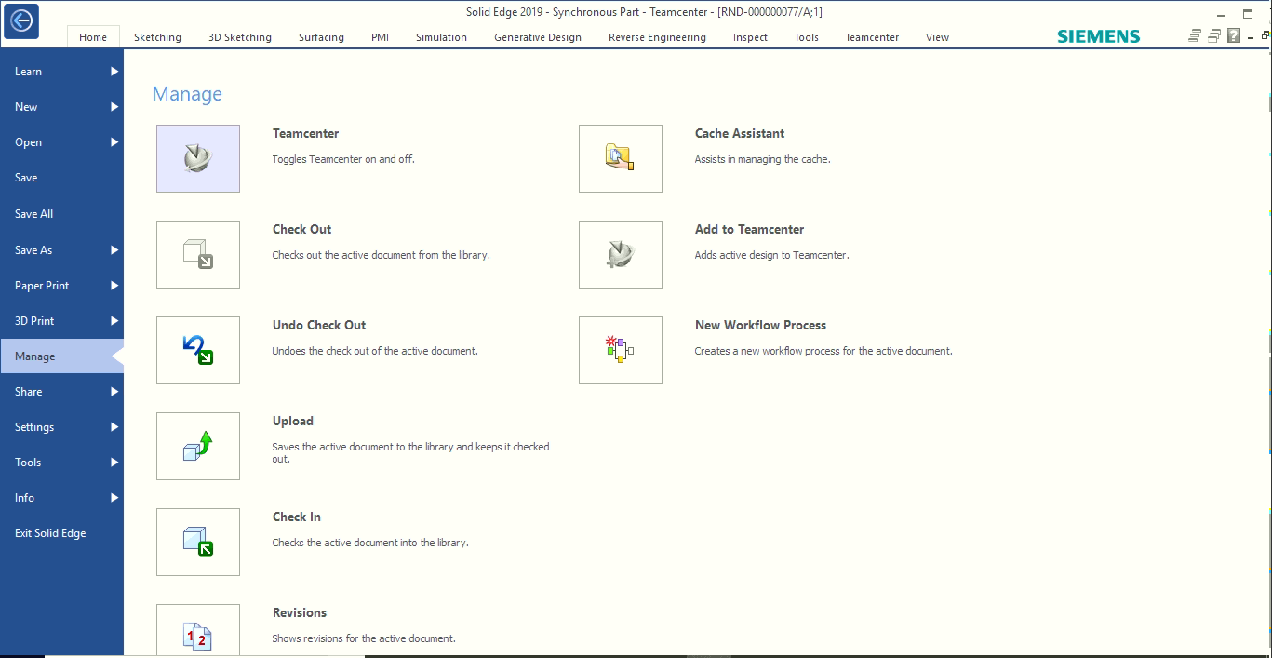

Click Working Offline

